WEEK_02

An example of an array in a program

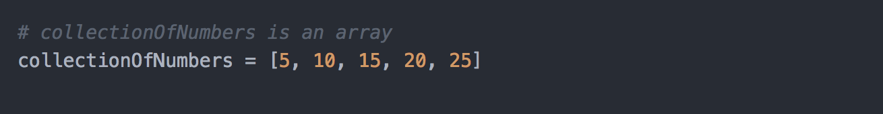

A function that uses the array

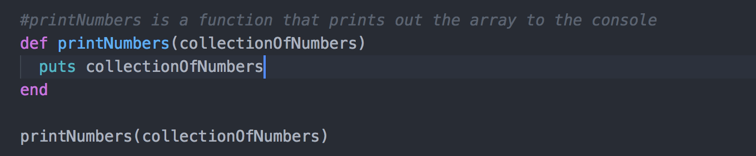

The result of the function running

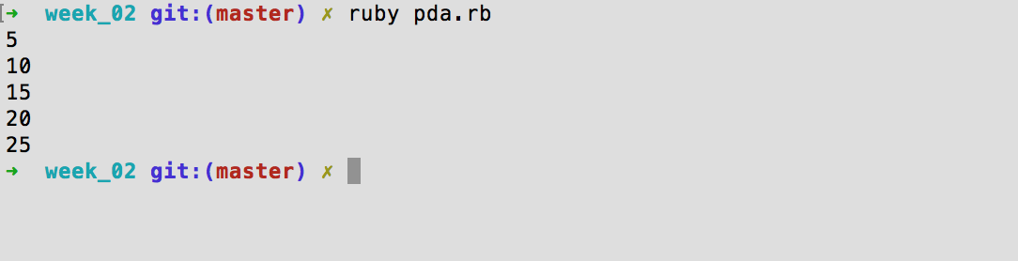

An example of a hash in a program



A function that uses the hash

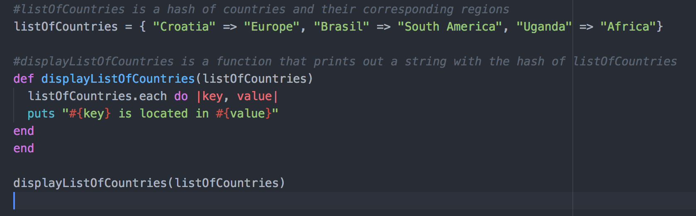

The result of the function running

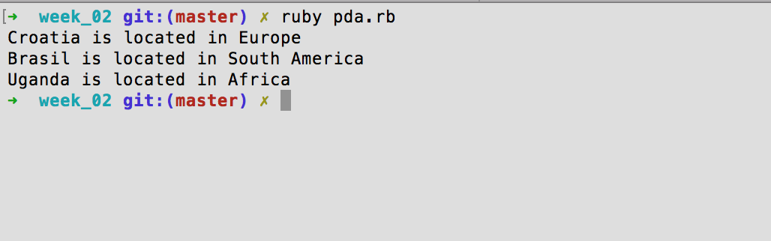

WEEK_03

An example of a function that searches data

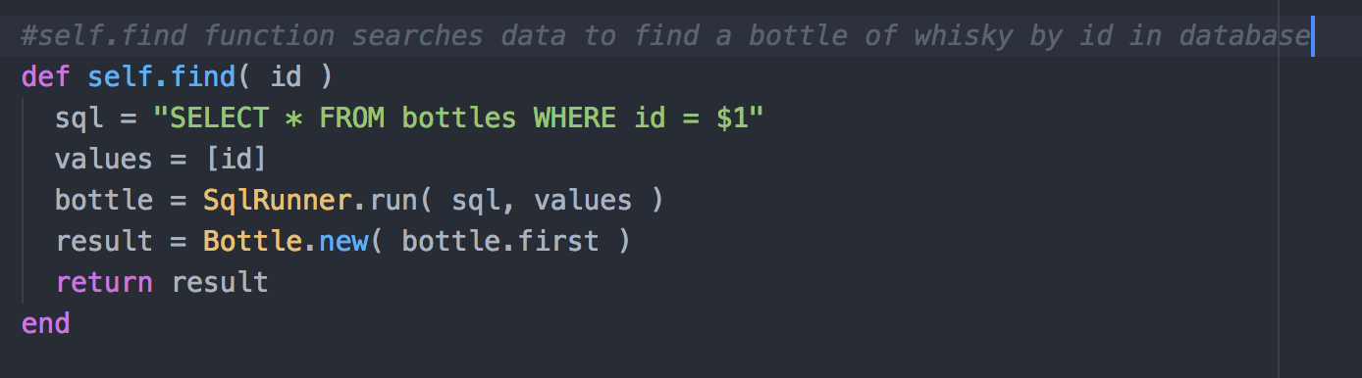

The result of the function running

In the console

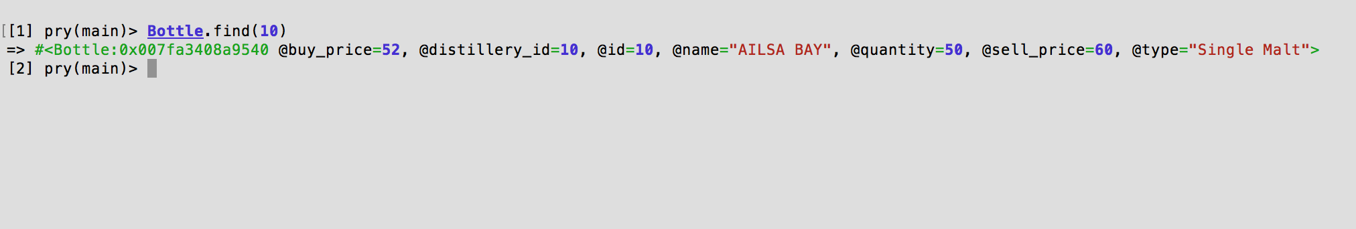

In the browser

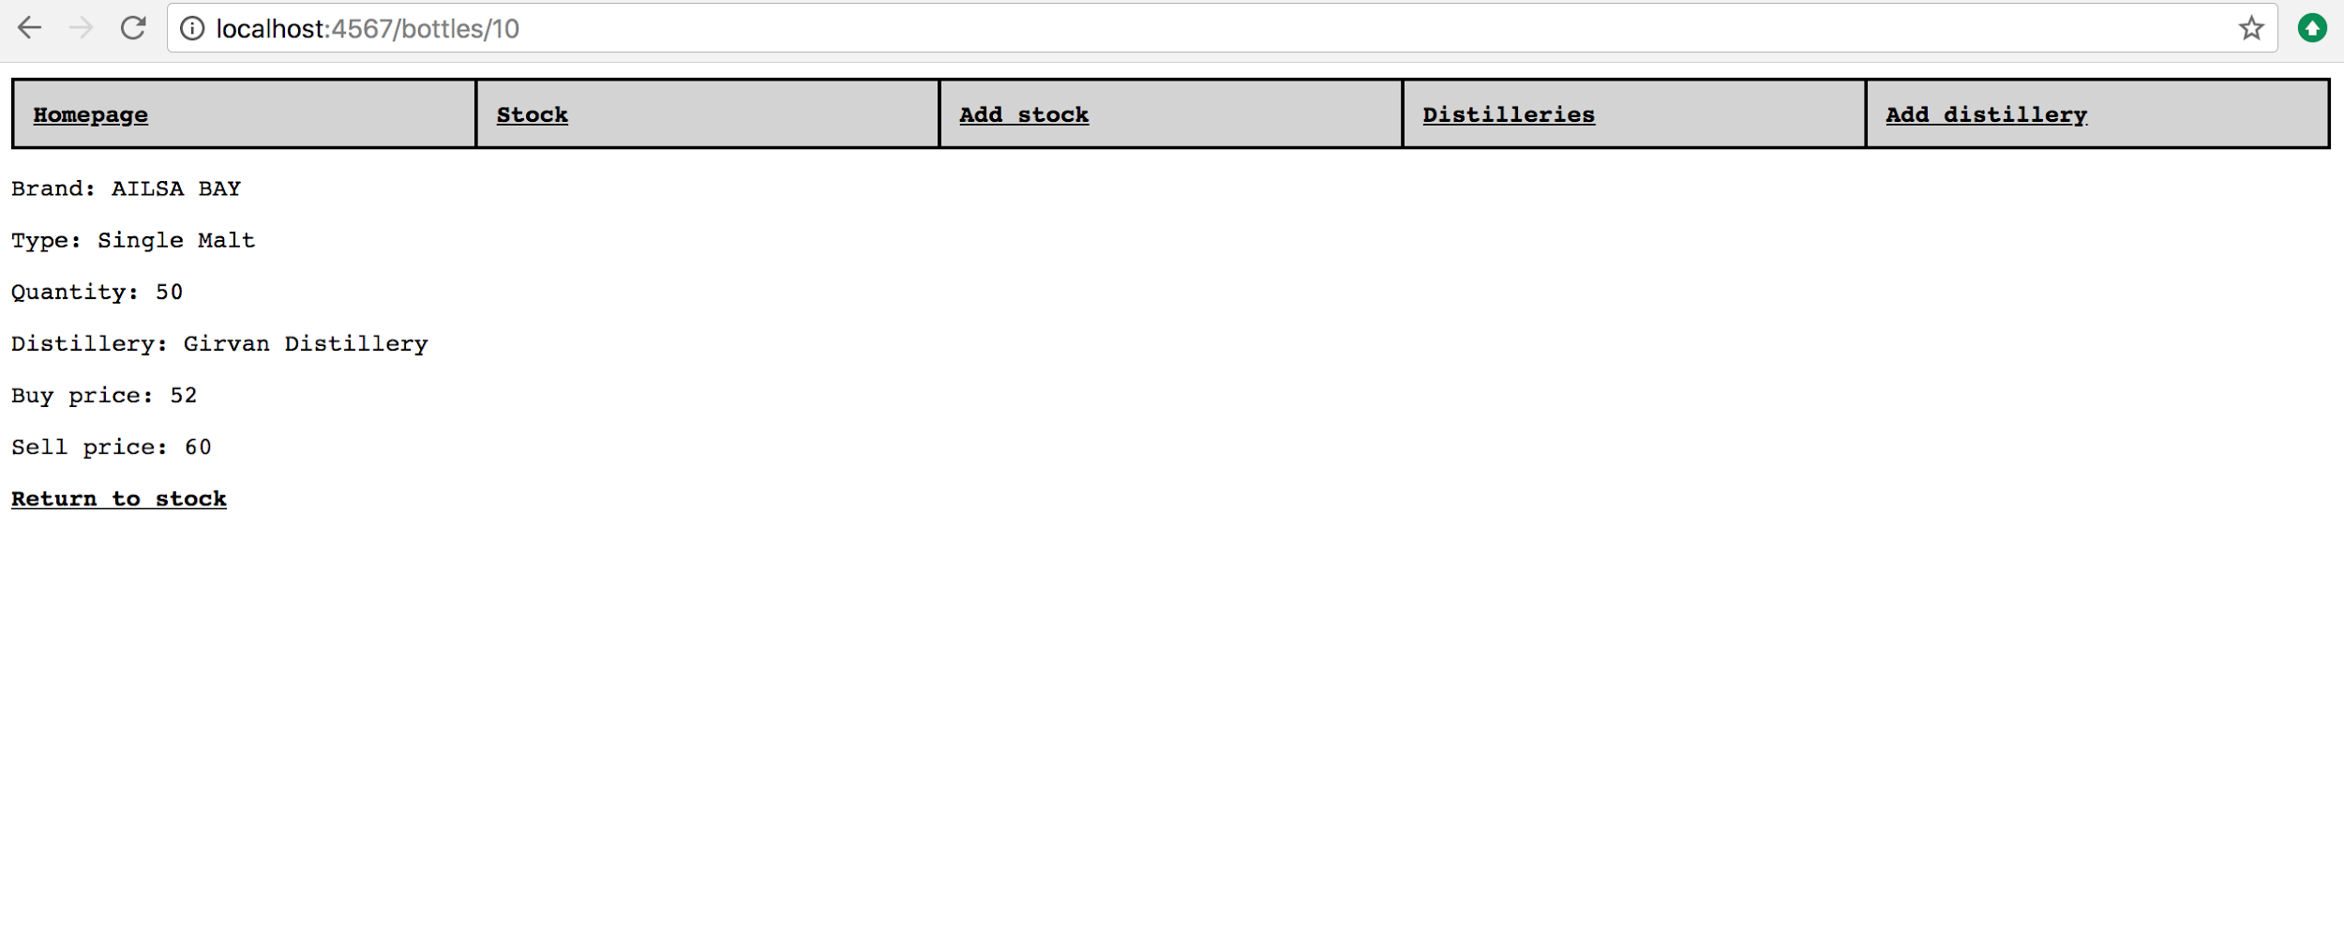

Function that sorts data

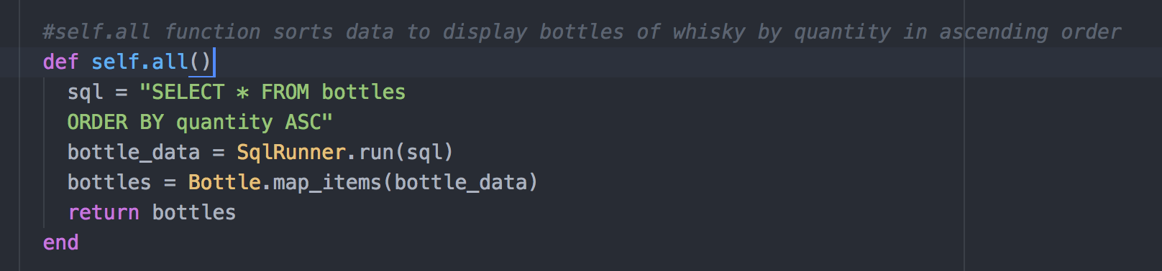

The result of the function running

**In the console** #data is not sorted here

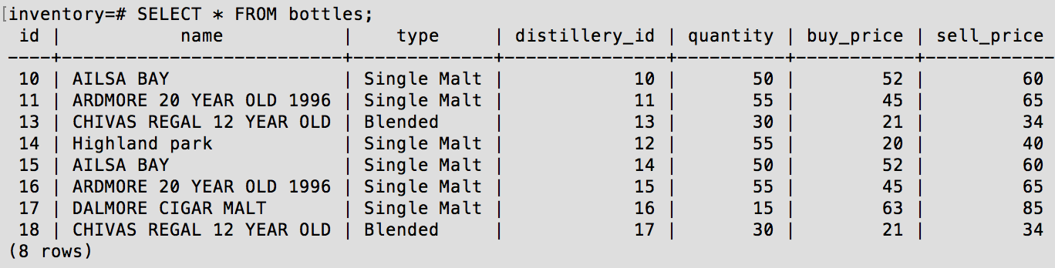

**In the browser** #data is now sorted and ordered by quantity in ascending order with 15 being the smallest quantity in the dataset

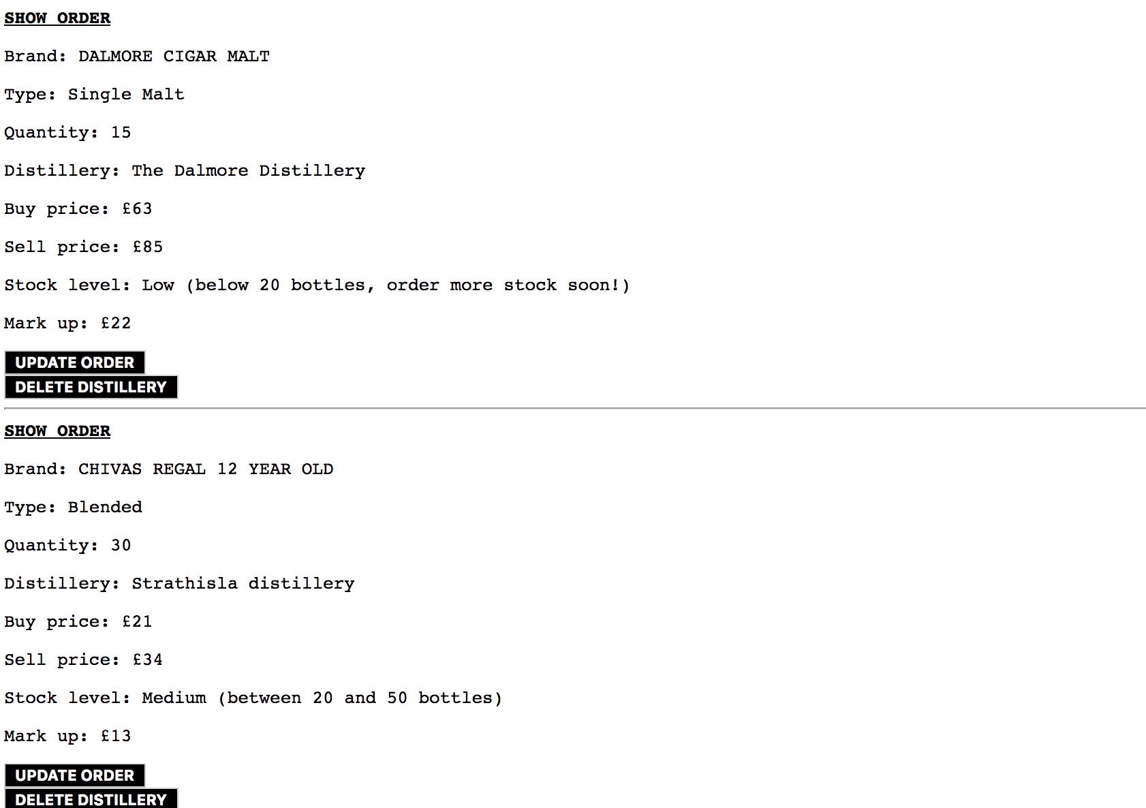

WEEK_05

A use case diagram

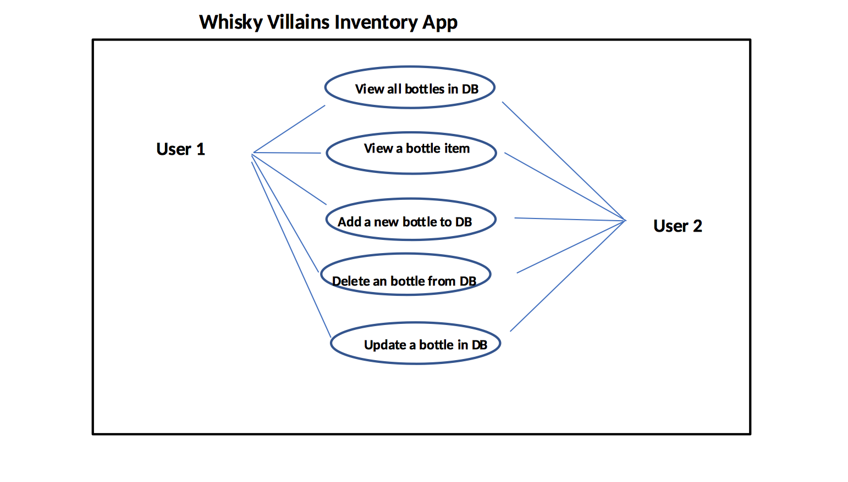

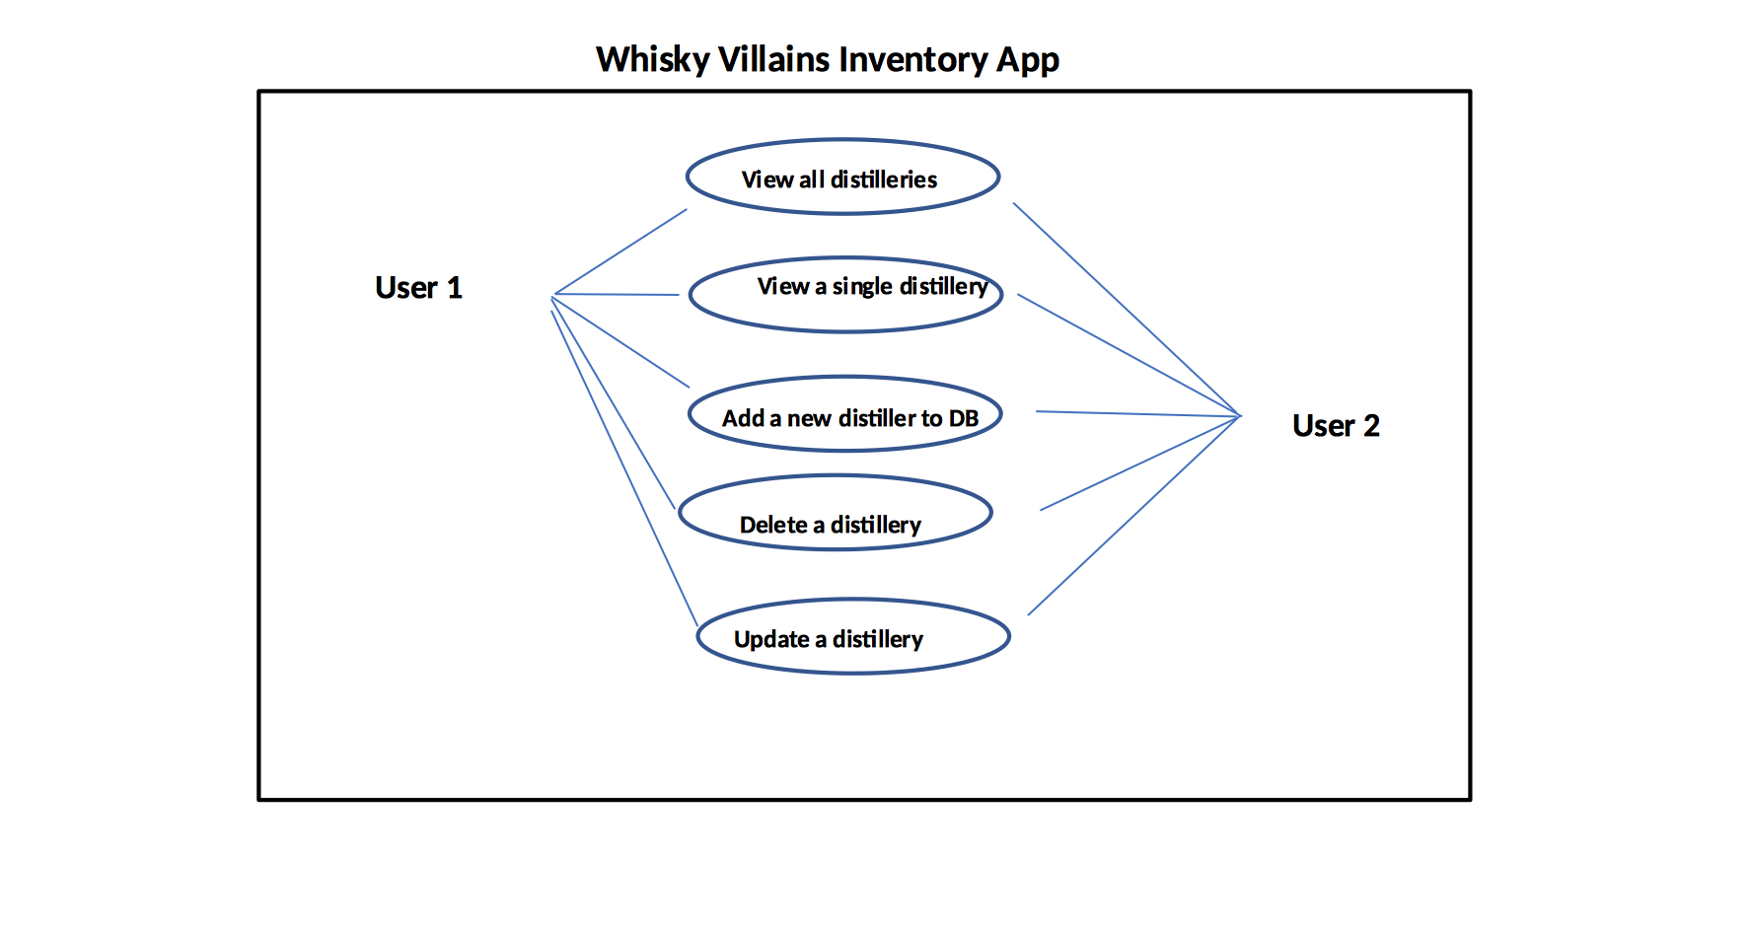

A class diagram

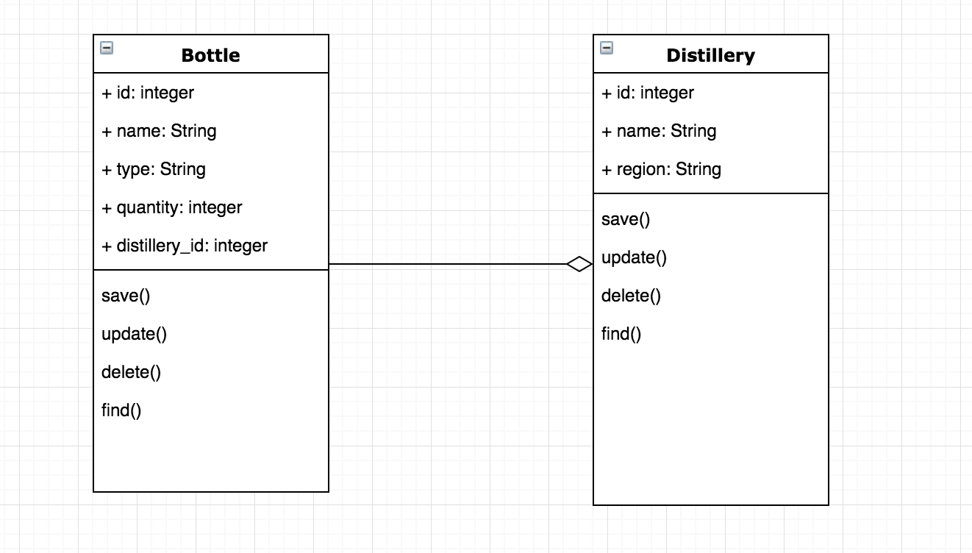

An object diagram

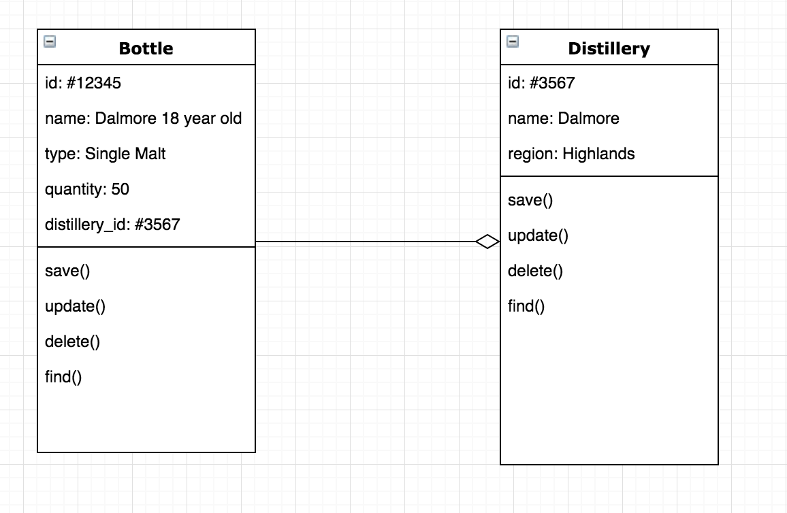

An activity diagram

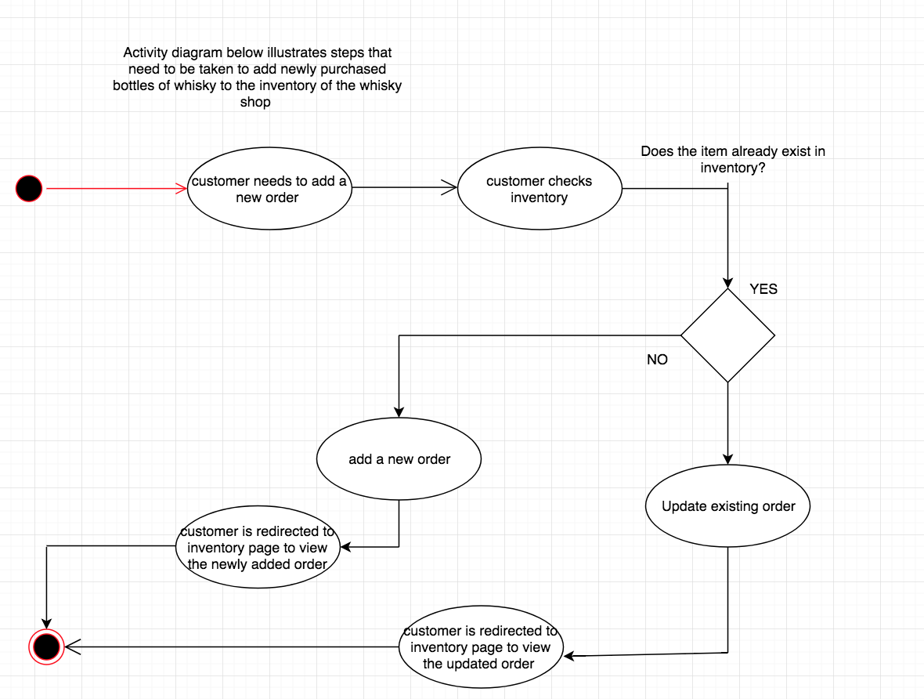

Implementation constraints plan

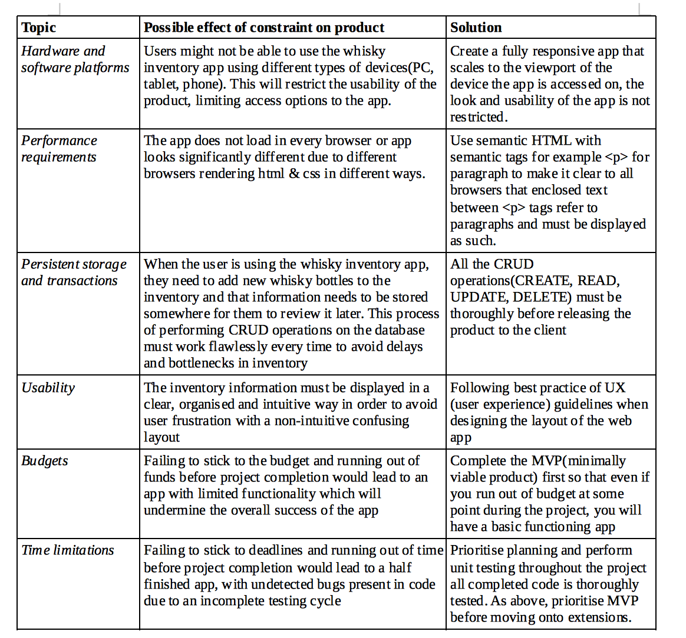

A site map

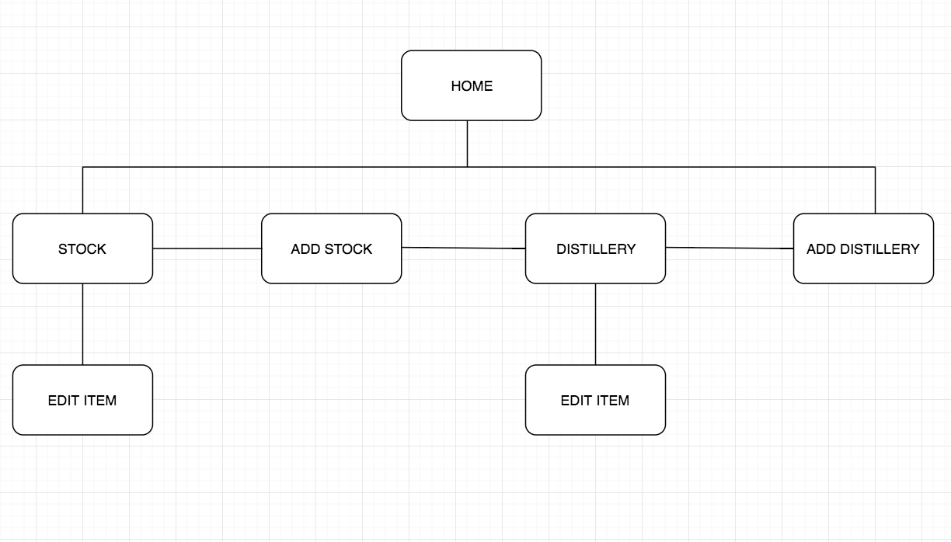

Produce two wireframes designs

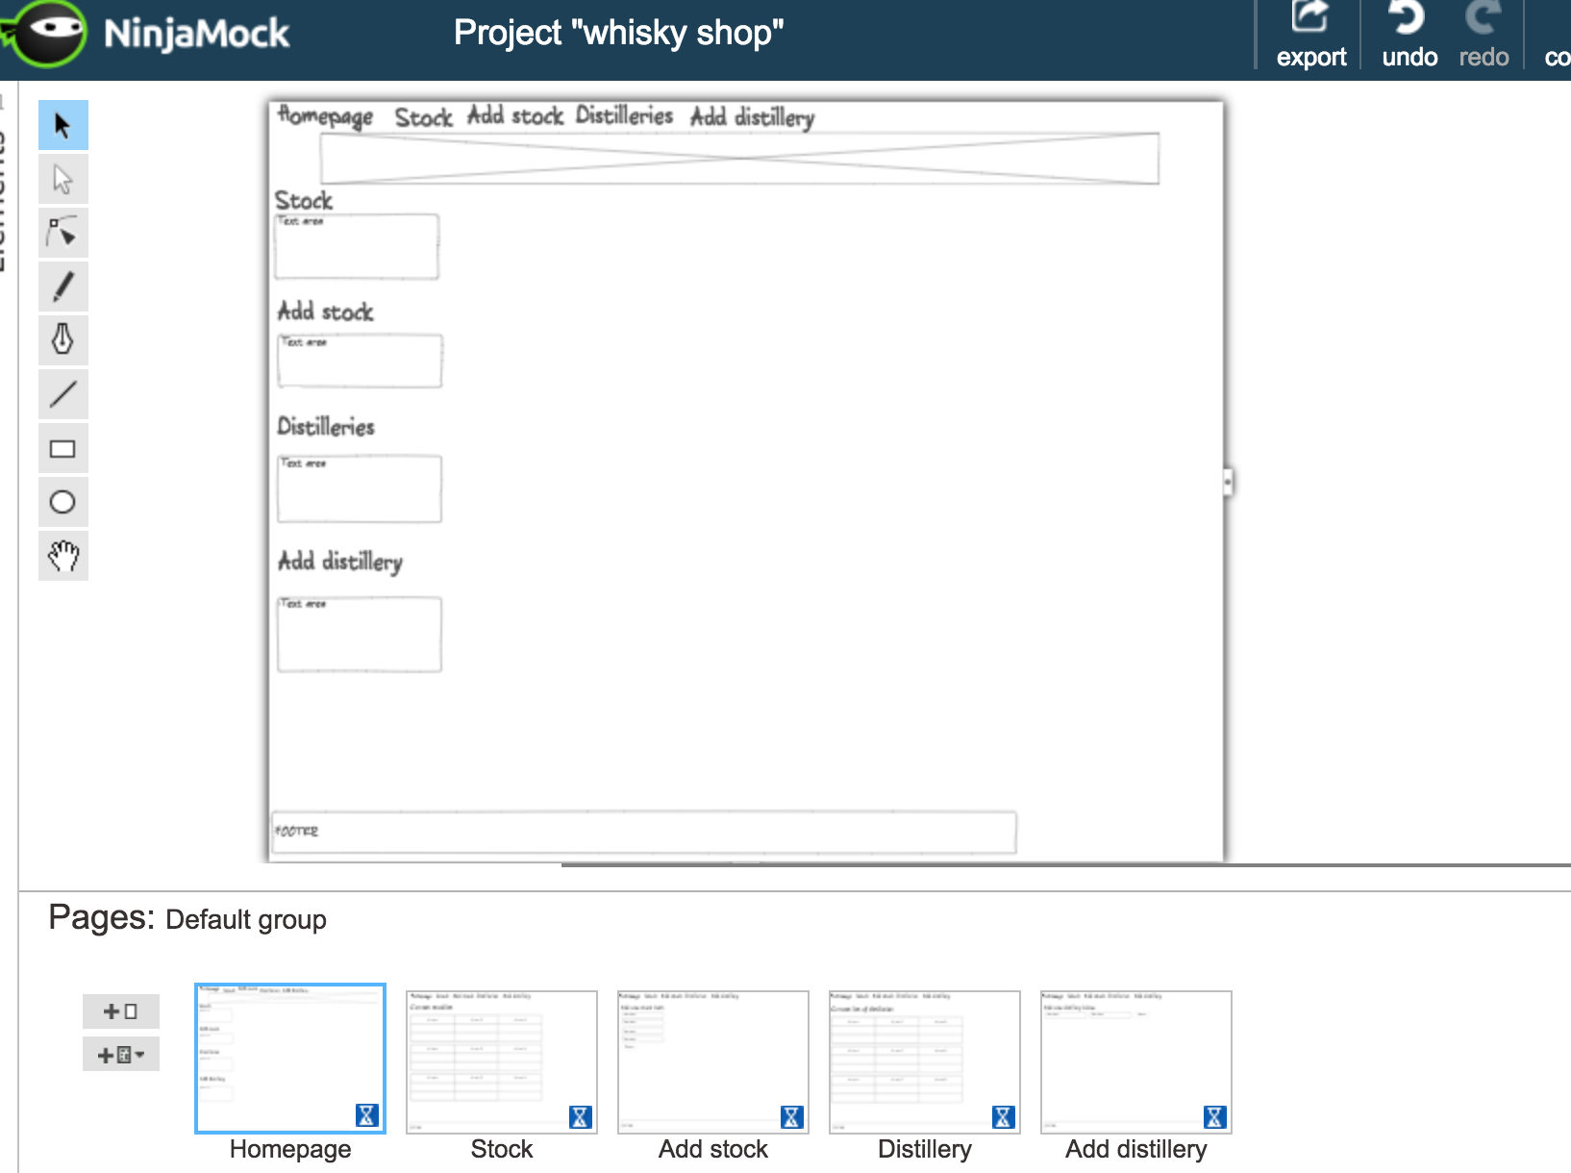

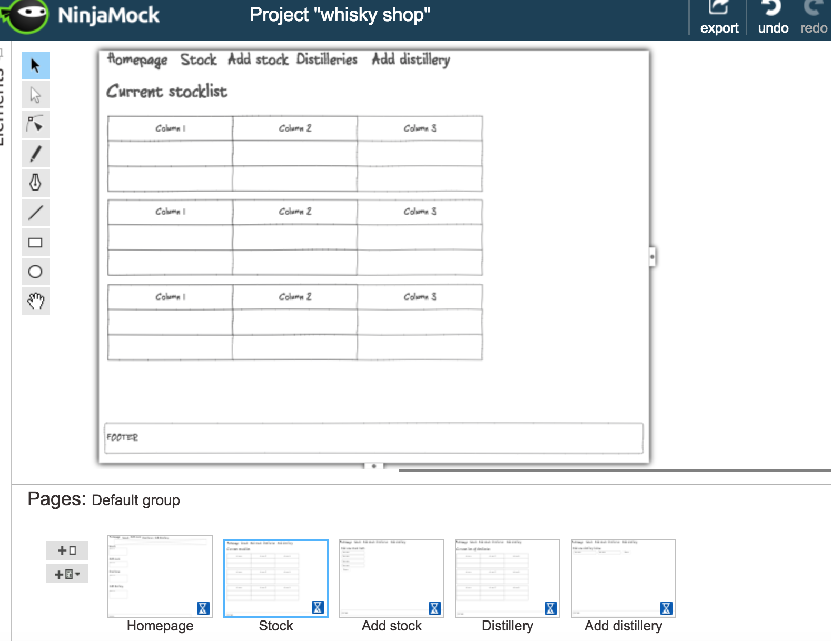

Take a screenshot of an example of pseudocode for a function

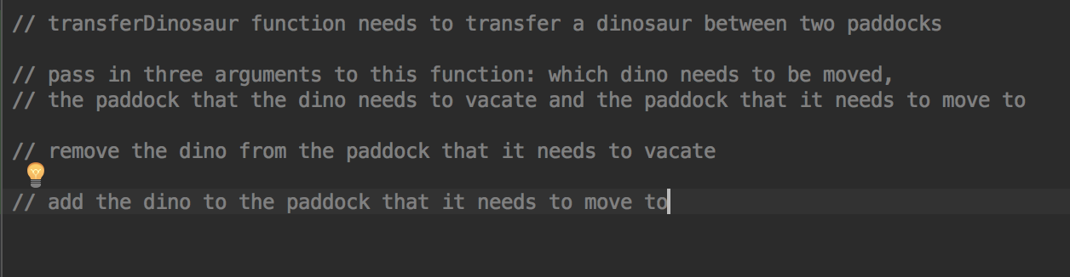

Show user input being processed according to design requirements. Take a screenshot of:

The user inputting something into your program

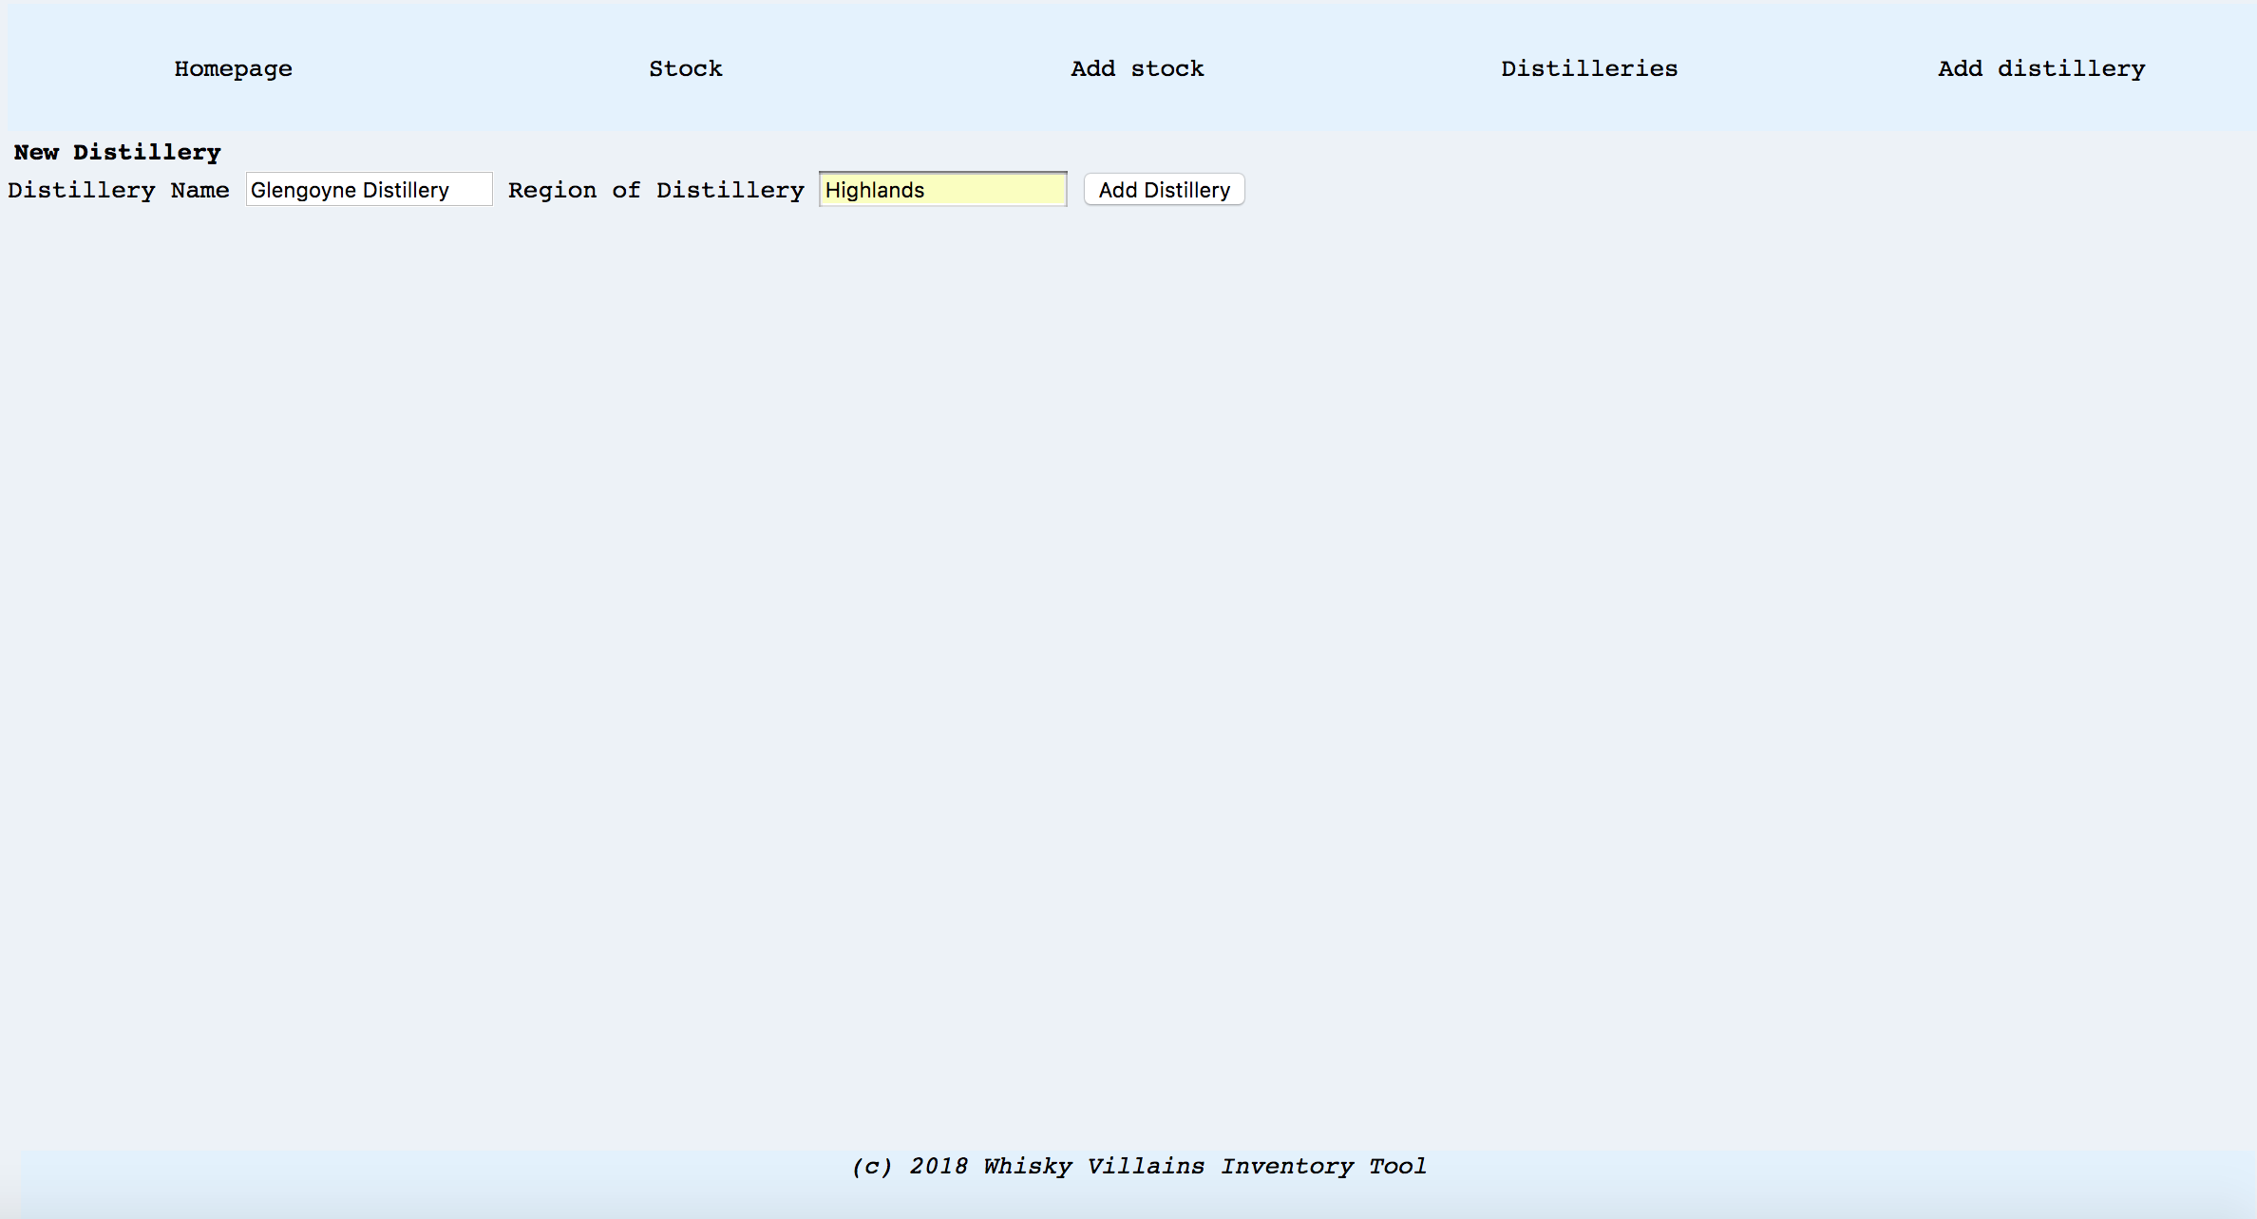

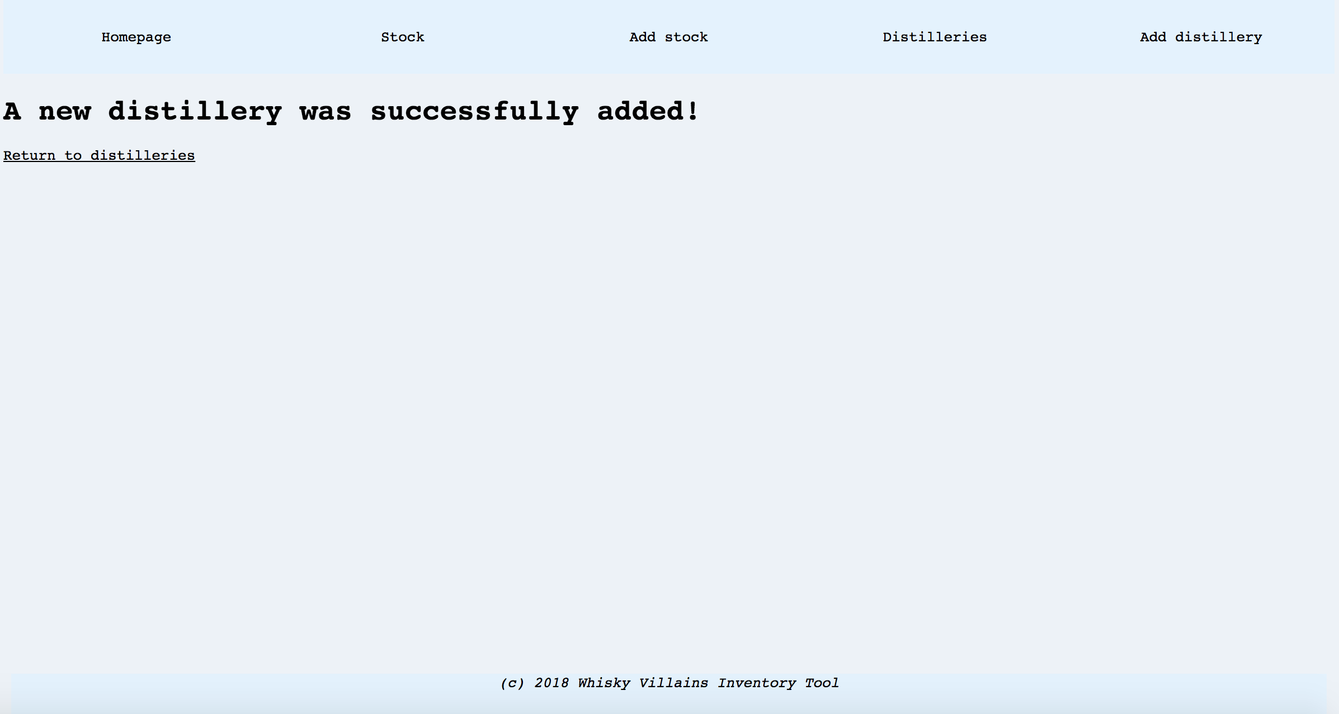

The user input being saved

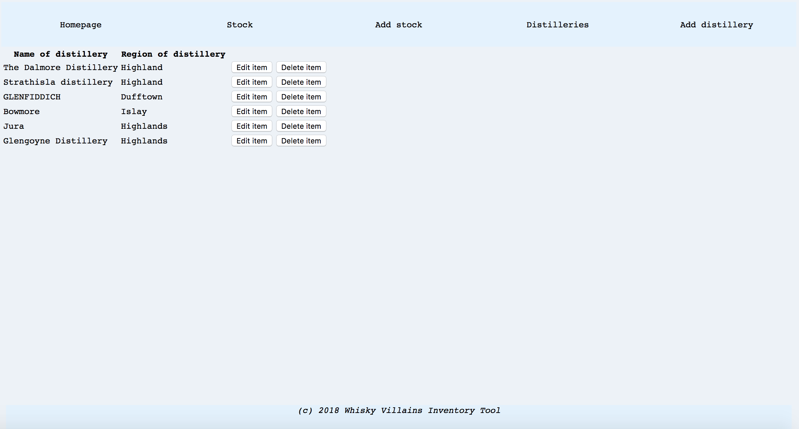

Glengoyne Distillery can be seen at the bottom of the list which corresponds to last item saved to database

Show an interaction with data persistence. Take a screenshot of:

Data being inputted into your program

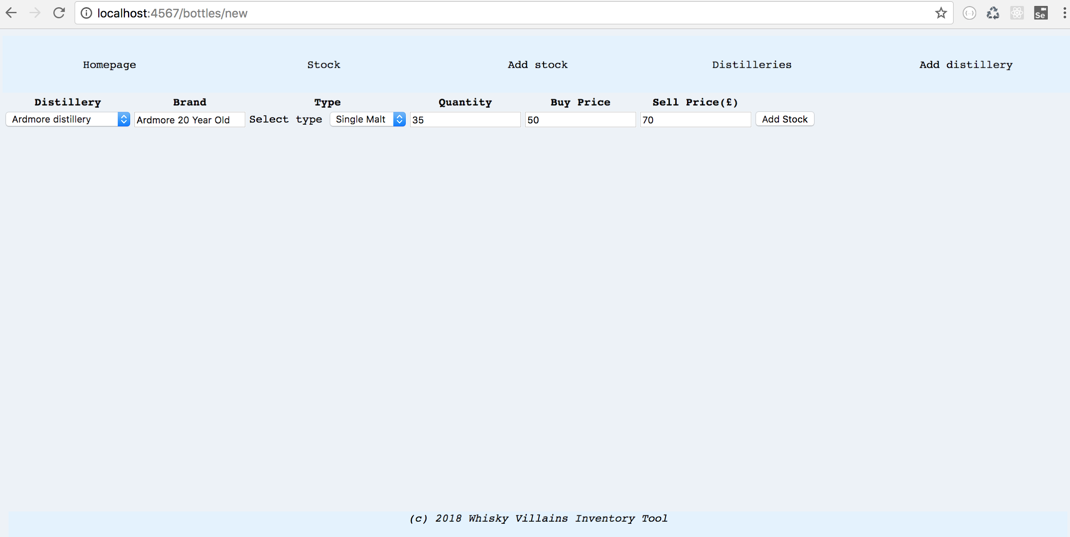

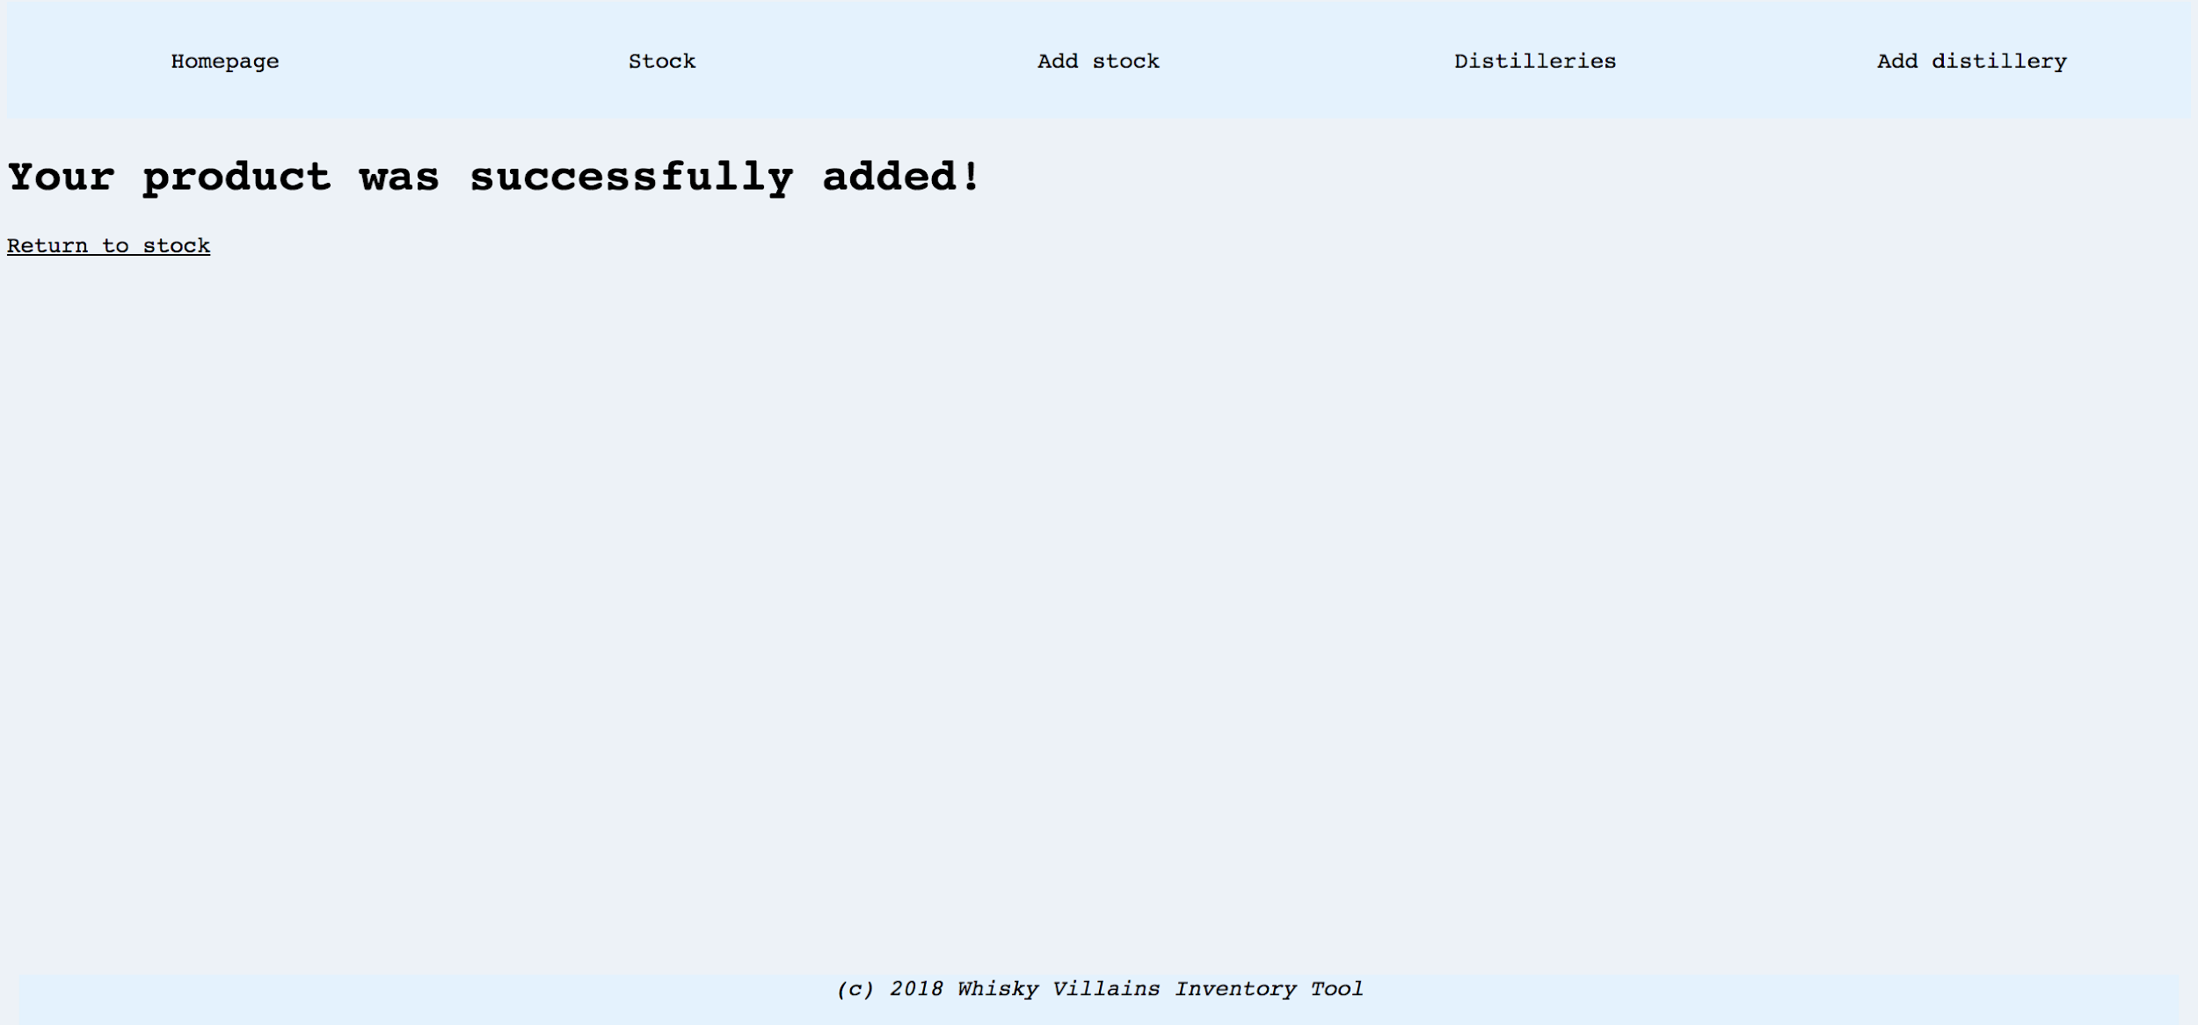

Confirmation of the data being saved

In the browser

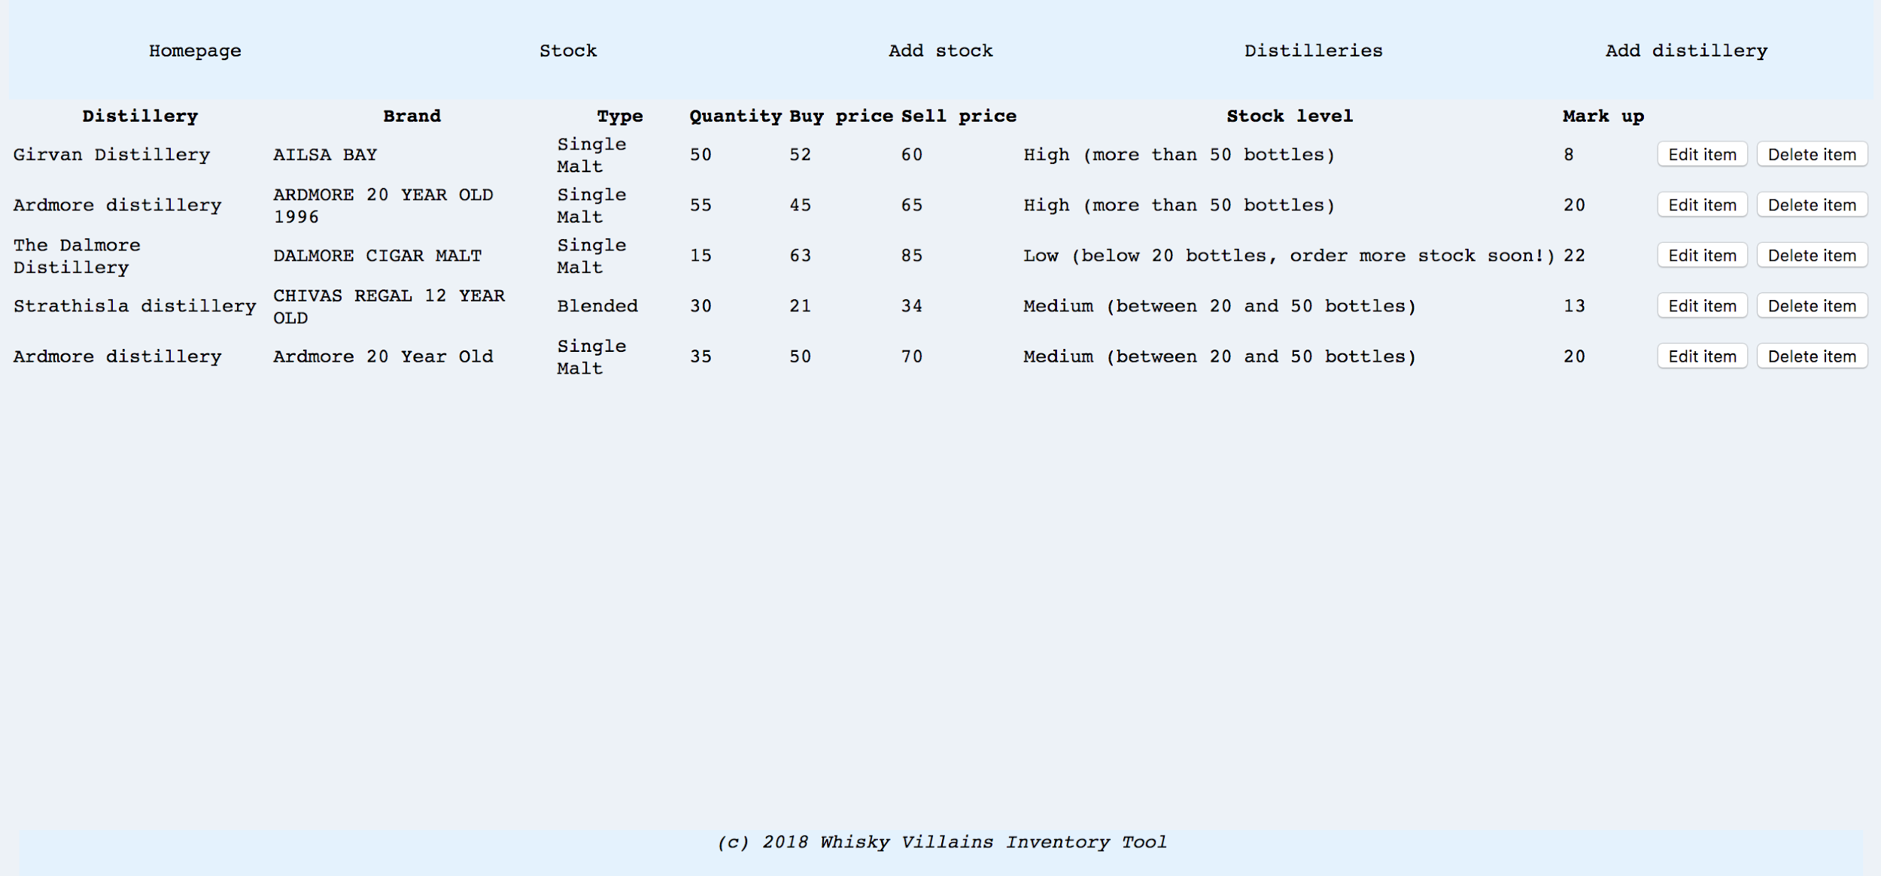

In the terminal

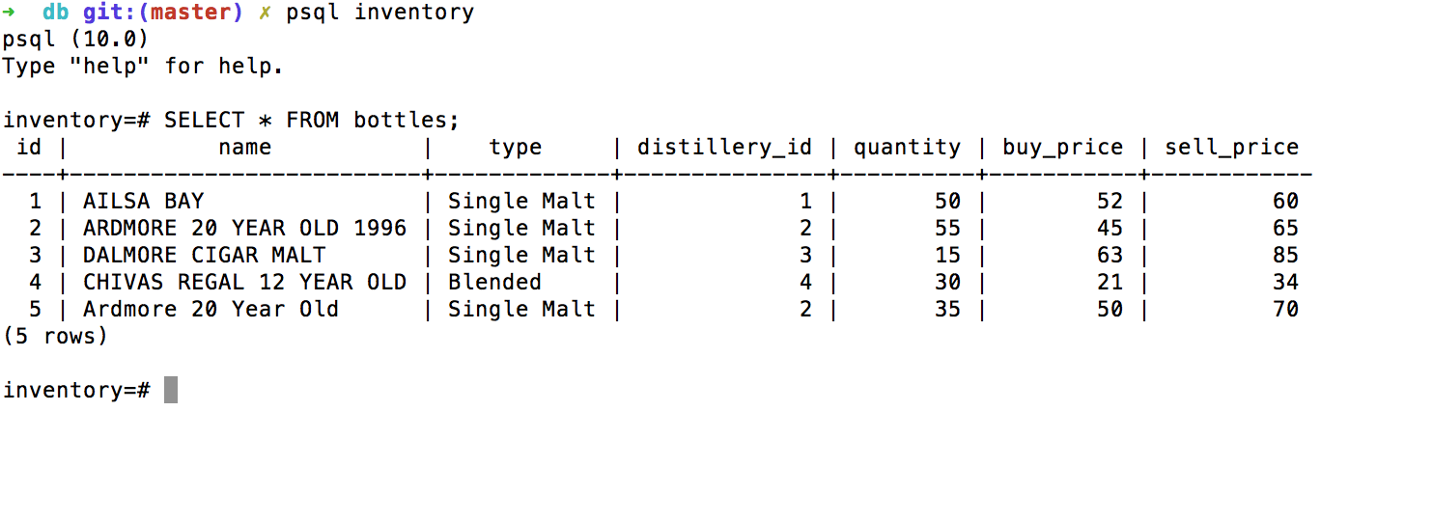

Show the correct output of results and feedback to user. Take a screenshot of:

The user requesting information or an action to be performed

User clicks on stock link in the navigation bar and expects to be taken to inventory page

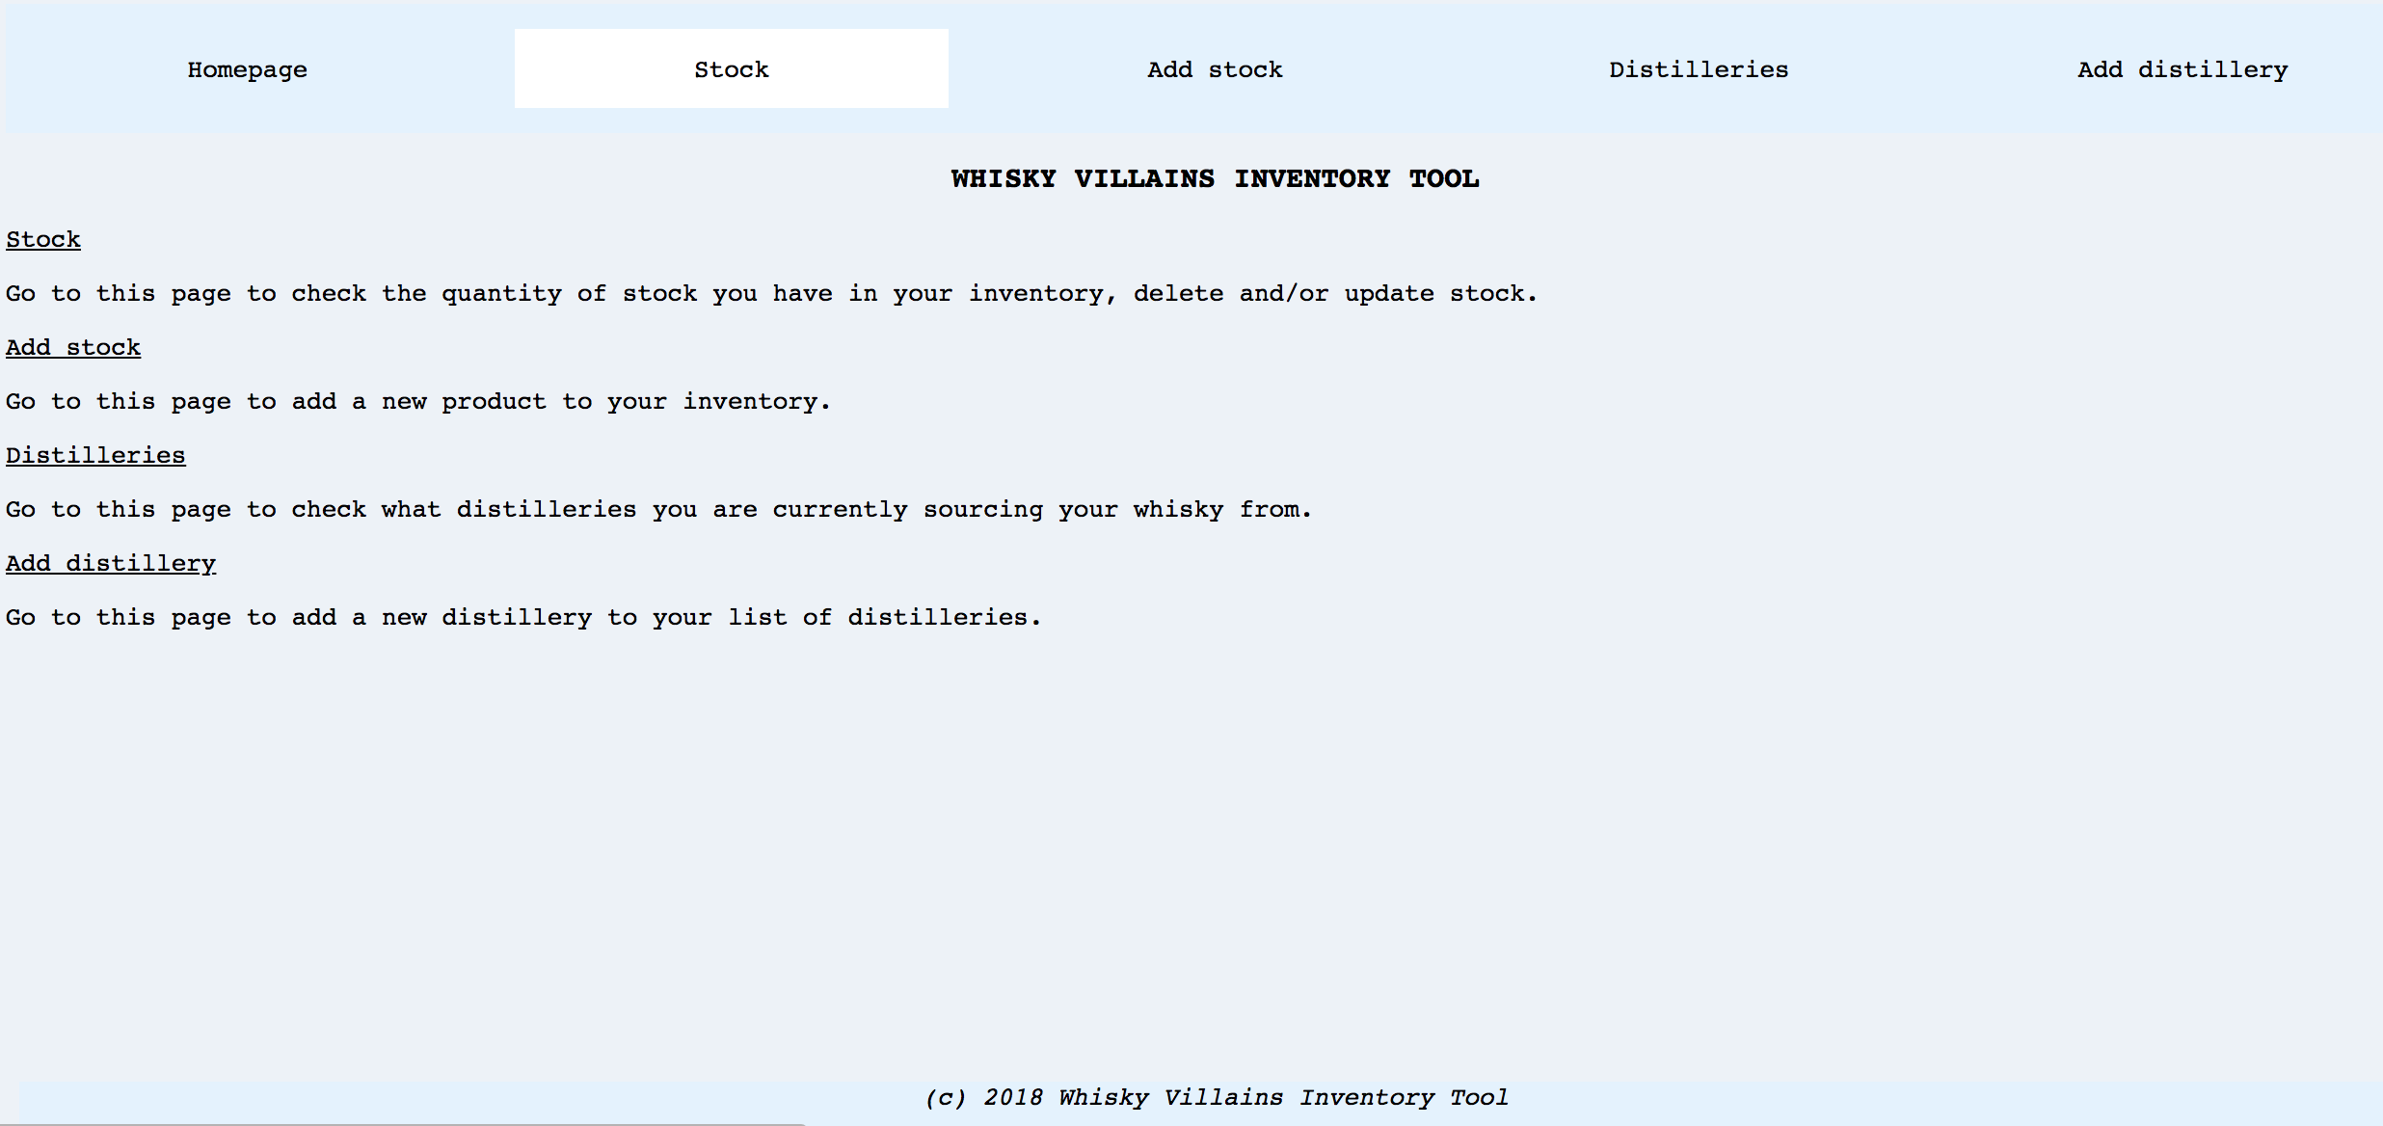

The user request being processed correctly and demonstrated in the program

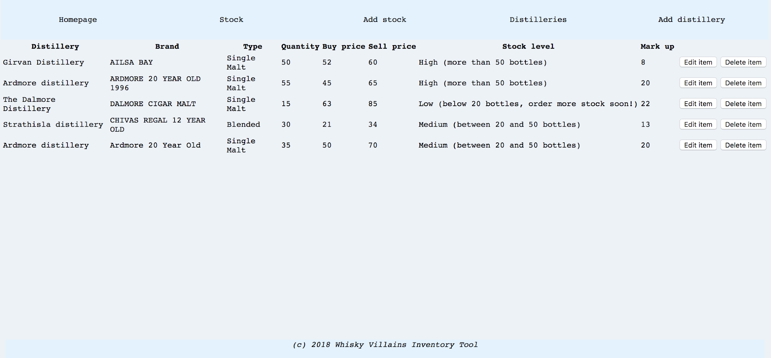

Clicking on “stock” link in navigation bar takes the user to the inventory page displayed in screenshot above

WEEK_6

Demonstrate the use of Polymorphism in a program

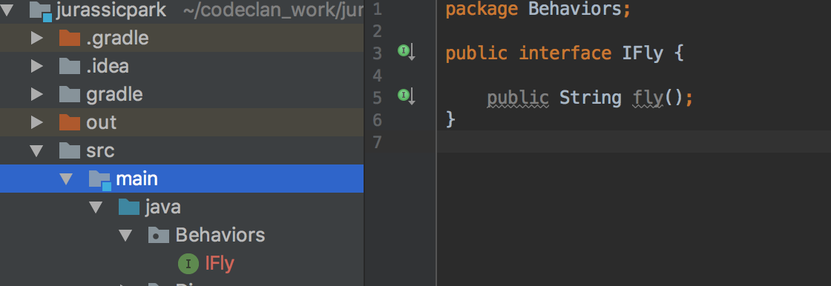

Pterosaur(flying dinosaurs) abstract class implements IFly interface. As it is an abstract class all its subclasses implement the IFly interface too.

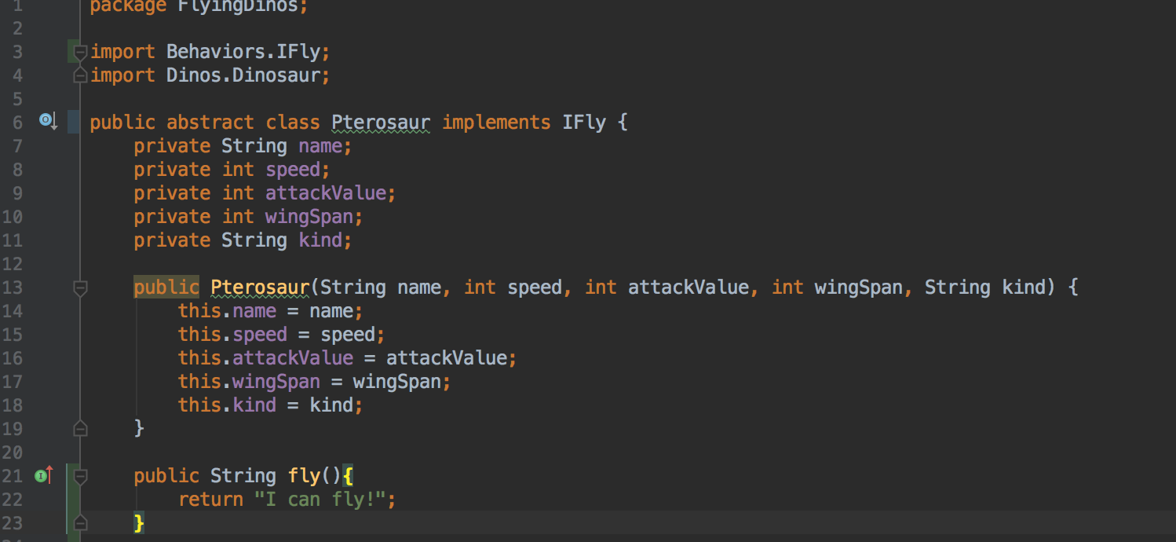

In the Park class, “IFly” objects are placed into an ArrayList called ‘predators’ to separate them from non flying dinosaurs who, in this scenario, are their prey.

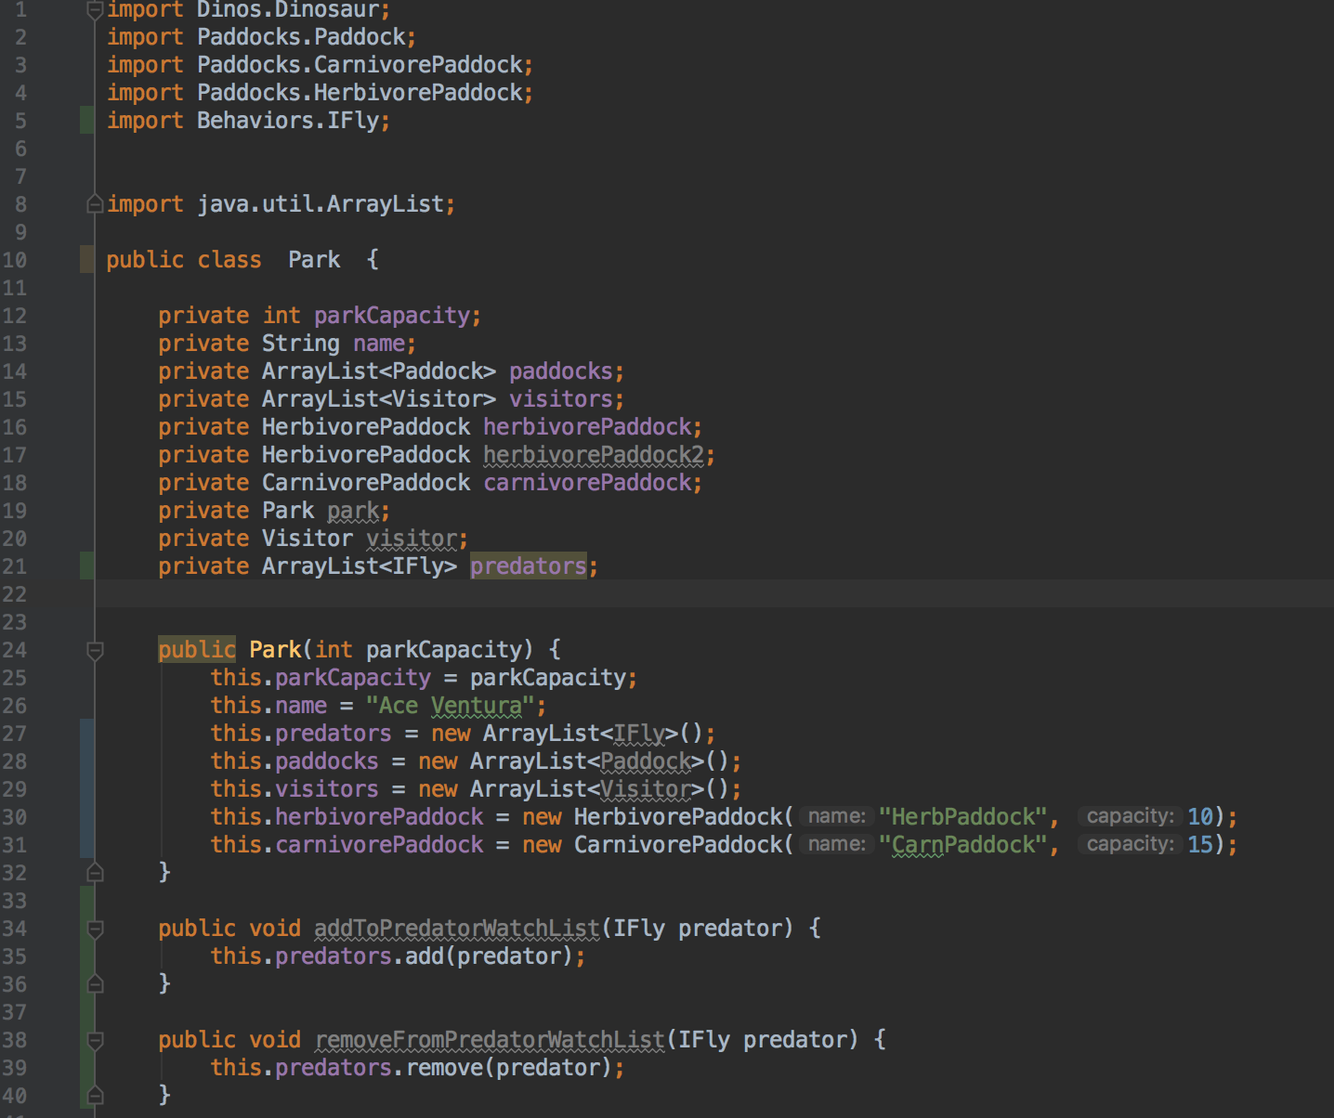

addToPredatorWatchList() adds IFly objects to an ArrayList of predators.

removeFromPredatorWatchList() removes IFly objects from the ArrayList of predators.

WEEK_9

Below is an inheritance diagram showing two abstract classes(Dinosaur & Pterosaur) and their respective subclasses

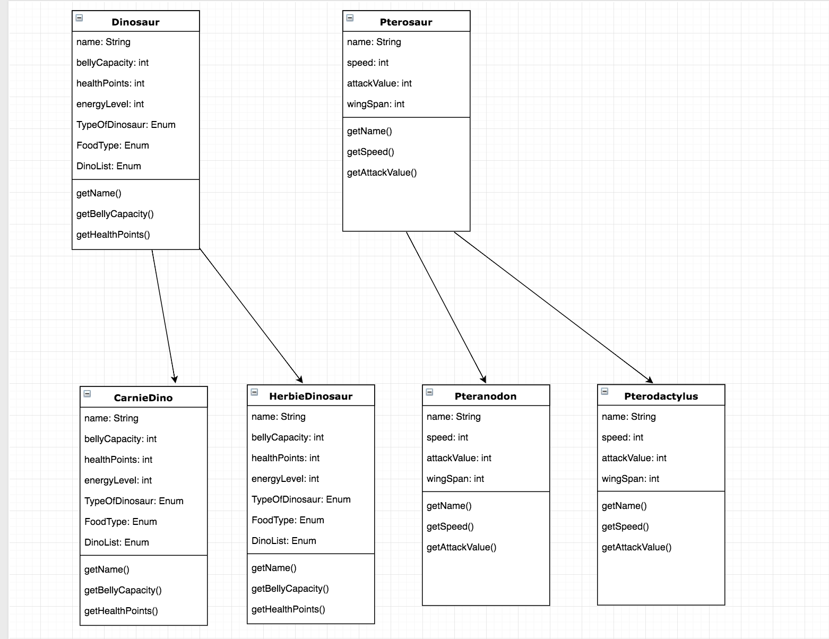

Take an example of encapsulation in a program

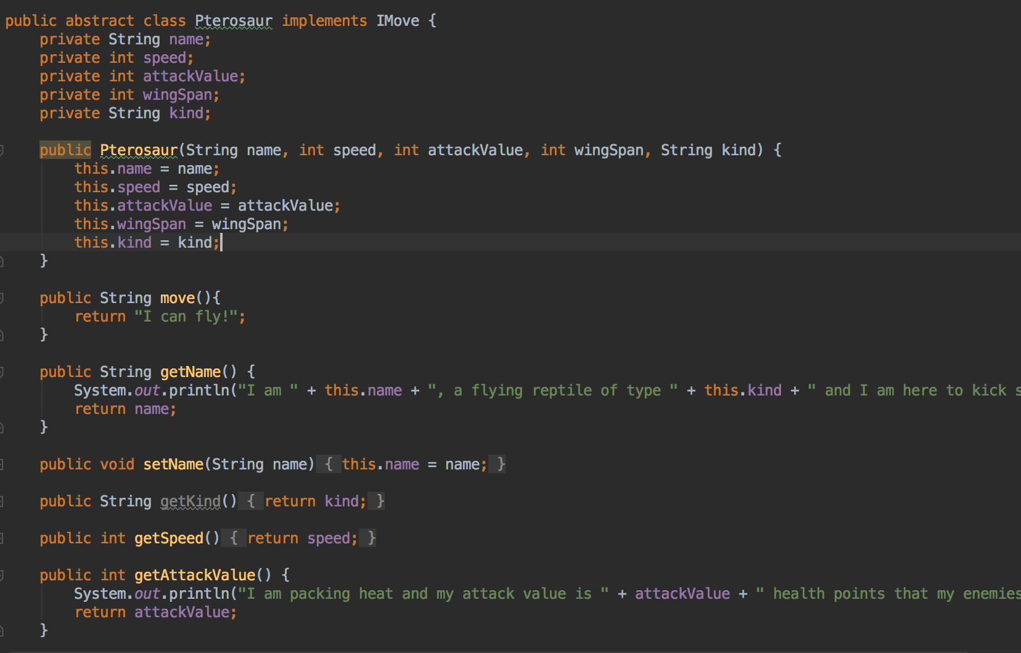

Take a screenshot of the use of Inheritance in a program. Take screenshots of:

Abstract class

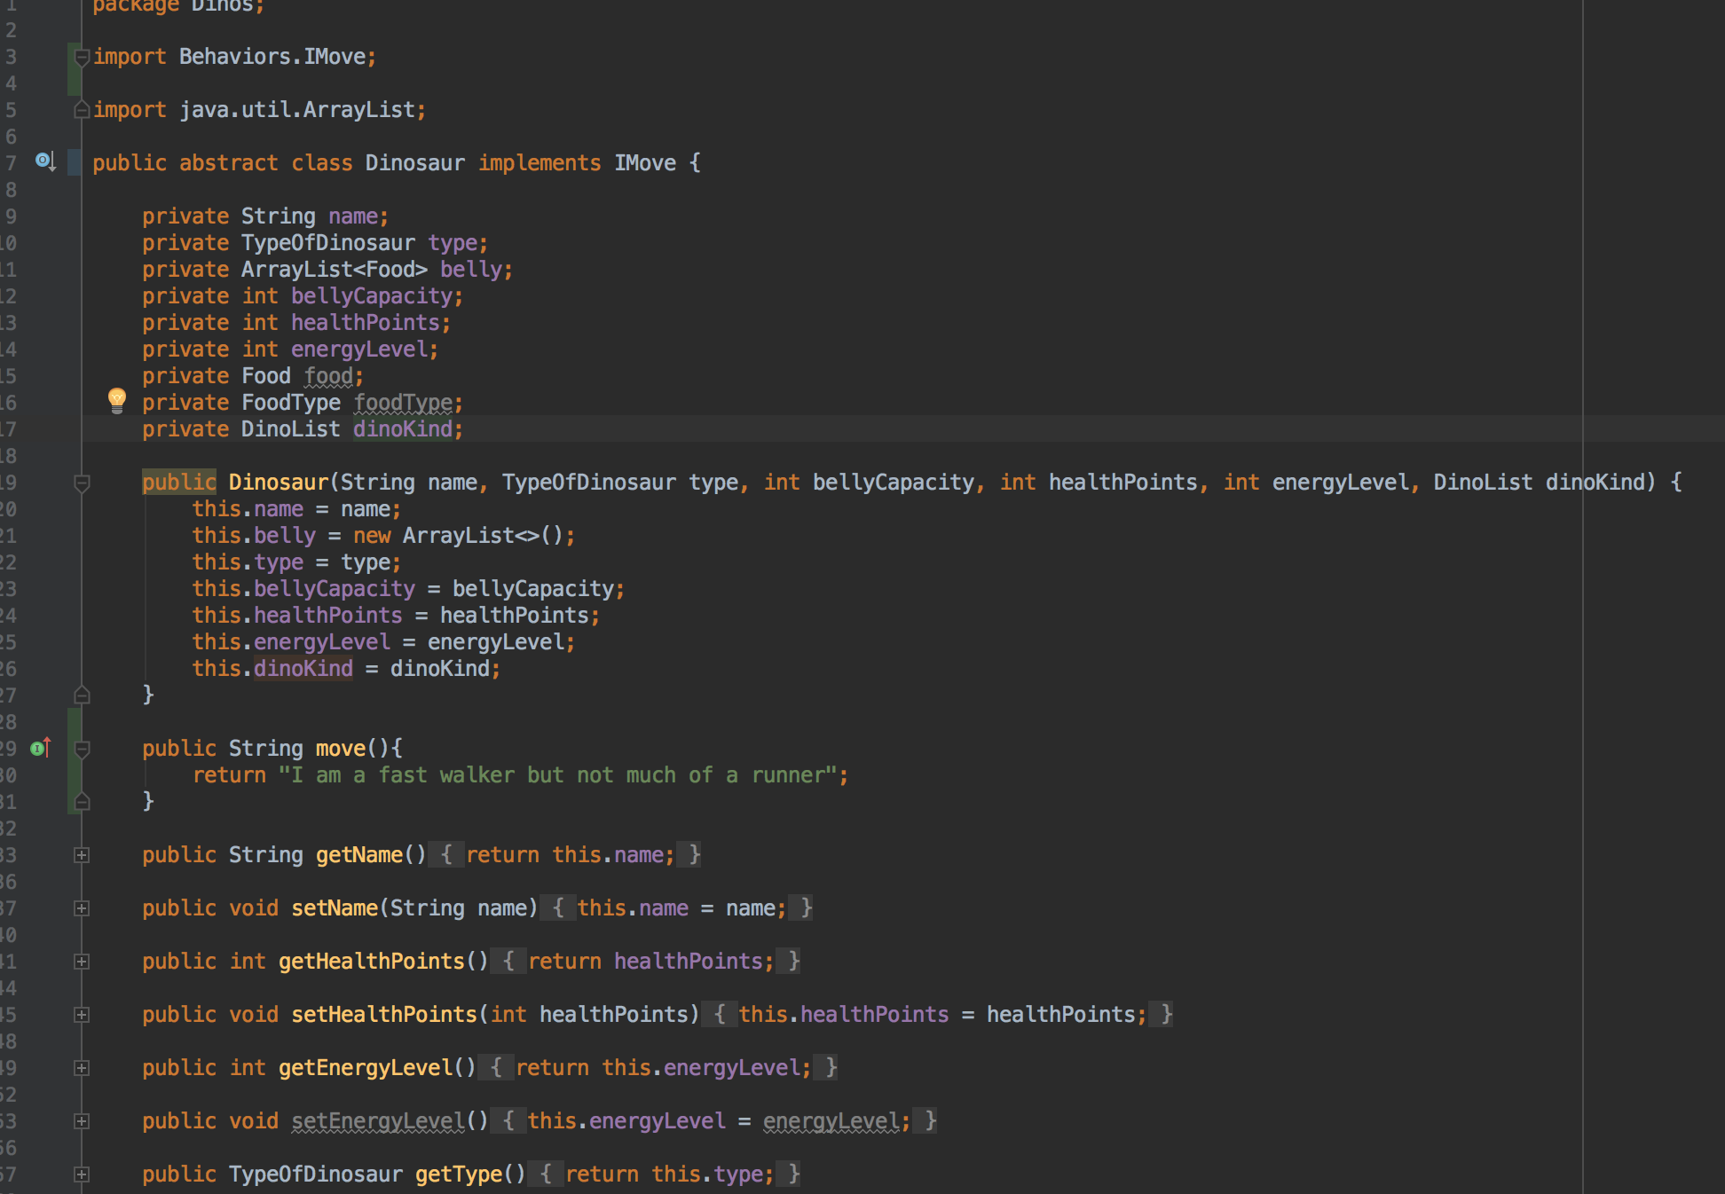

Subclass that inherit from abstract class “Dinosaur”

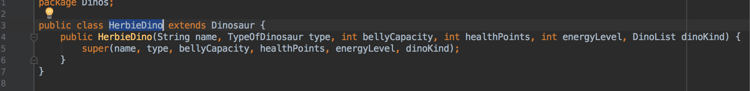

An object in the inherited class

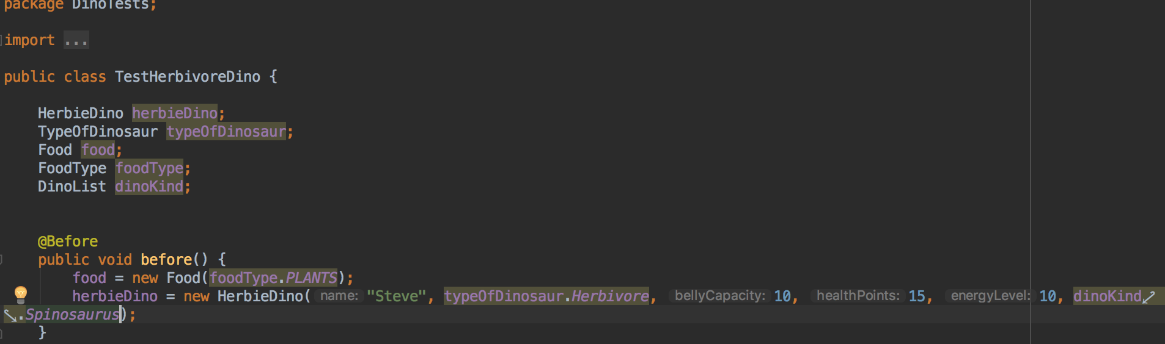

A method that uses the information inherited from another class

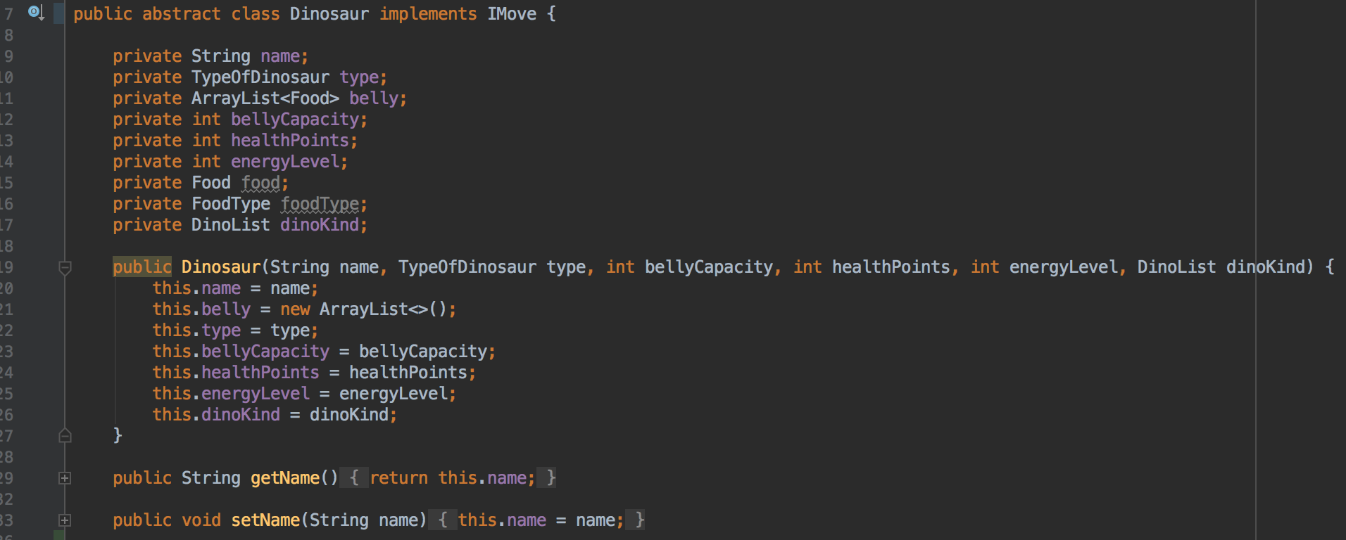

getName and setName are both methods on Dinosaur abstract class

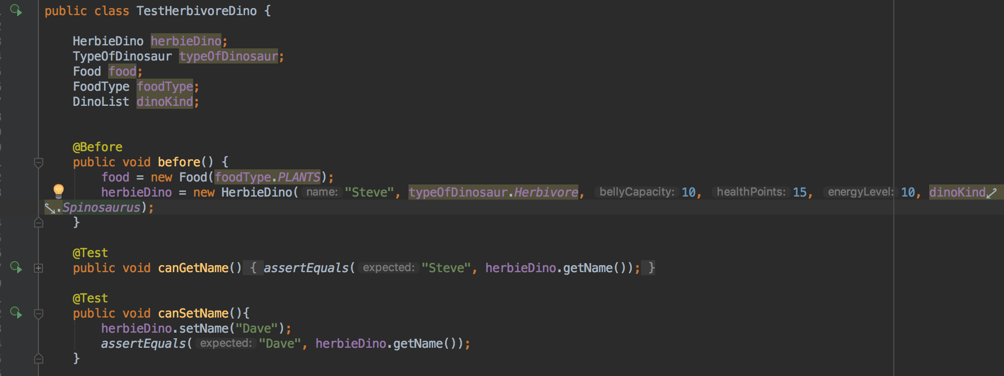

getName and setName are methods inherited from Dinosaur abstract class

Take a screenshot of one of your projects where you worked alone and attach the Github link

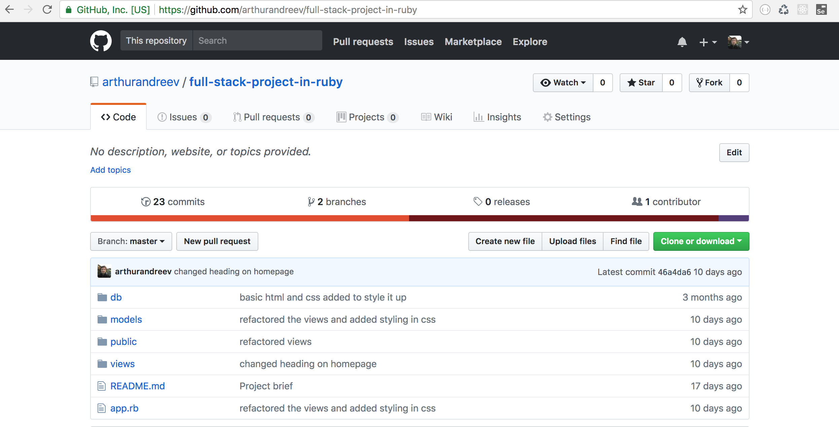

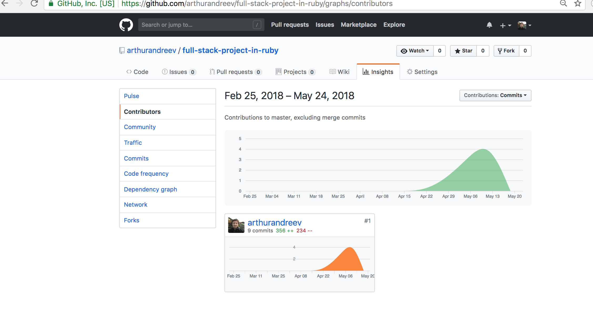

<https://github.com/arthurandreev/full-stack-project-in-ruby>

Take screenshots or photos of your planning and the different stages of development to show changes

Start of project

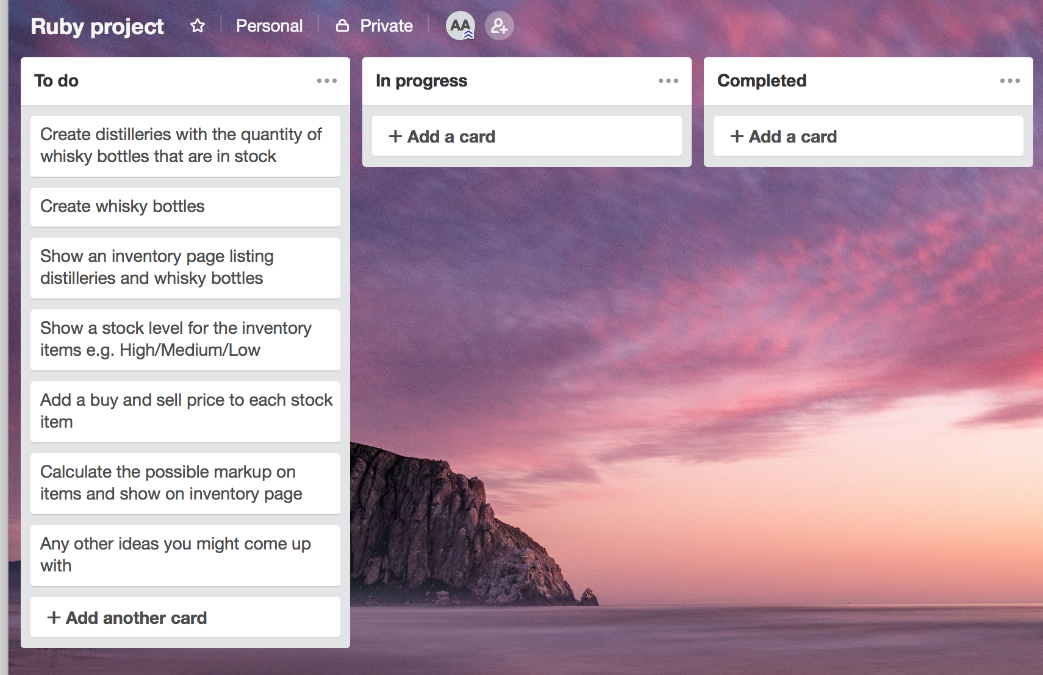

Halfway point

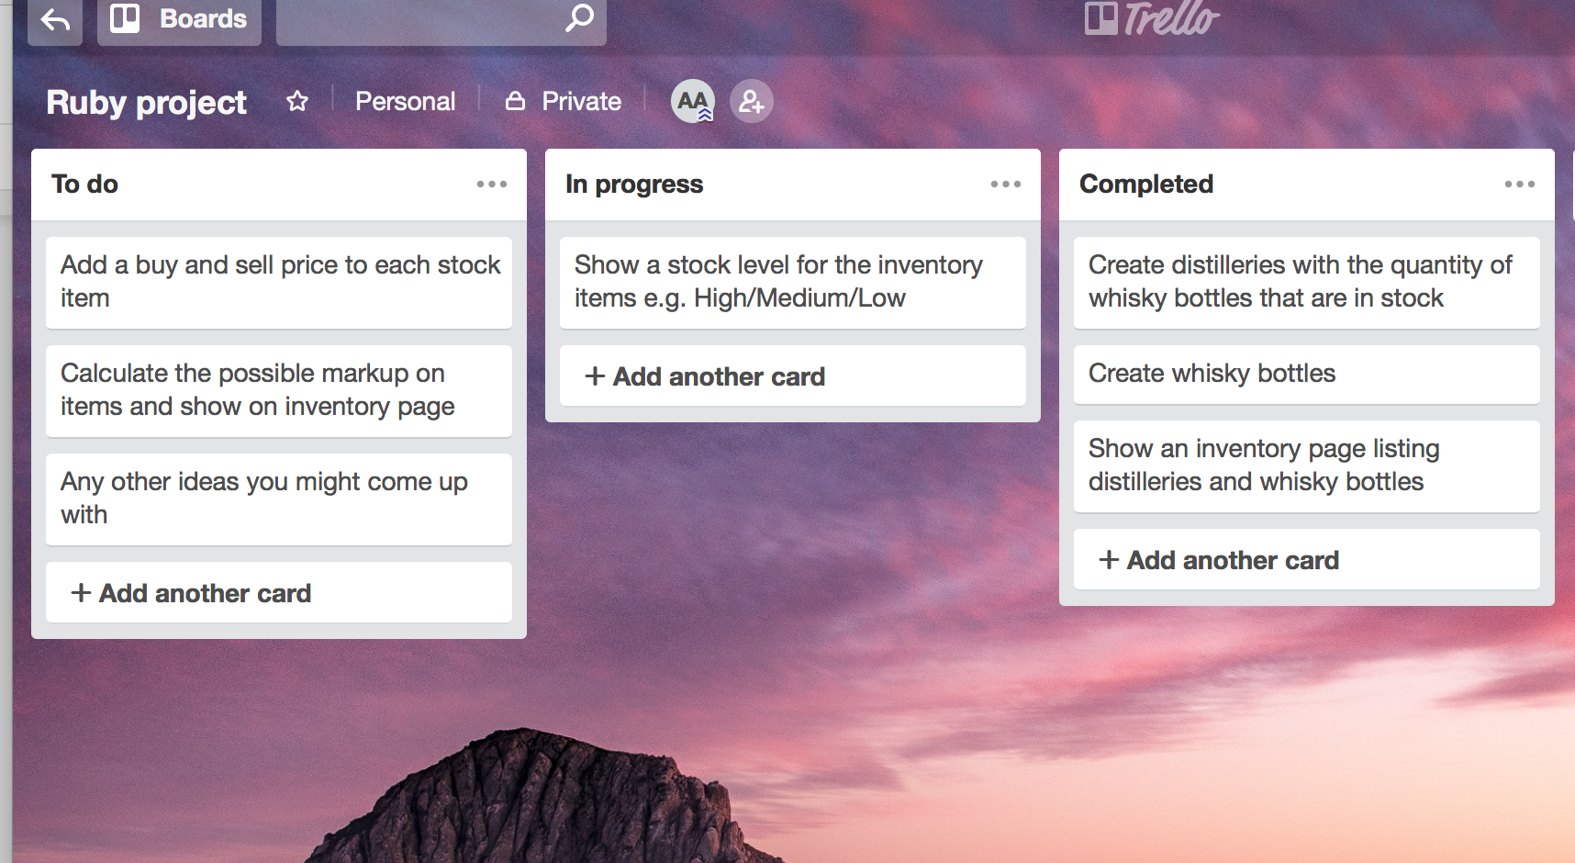

Completed project

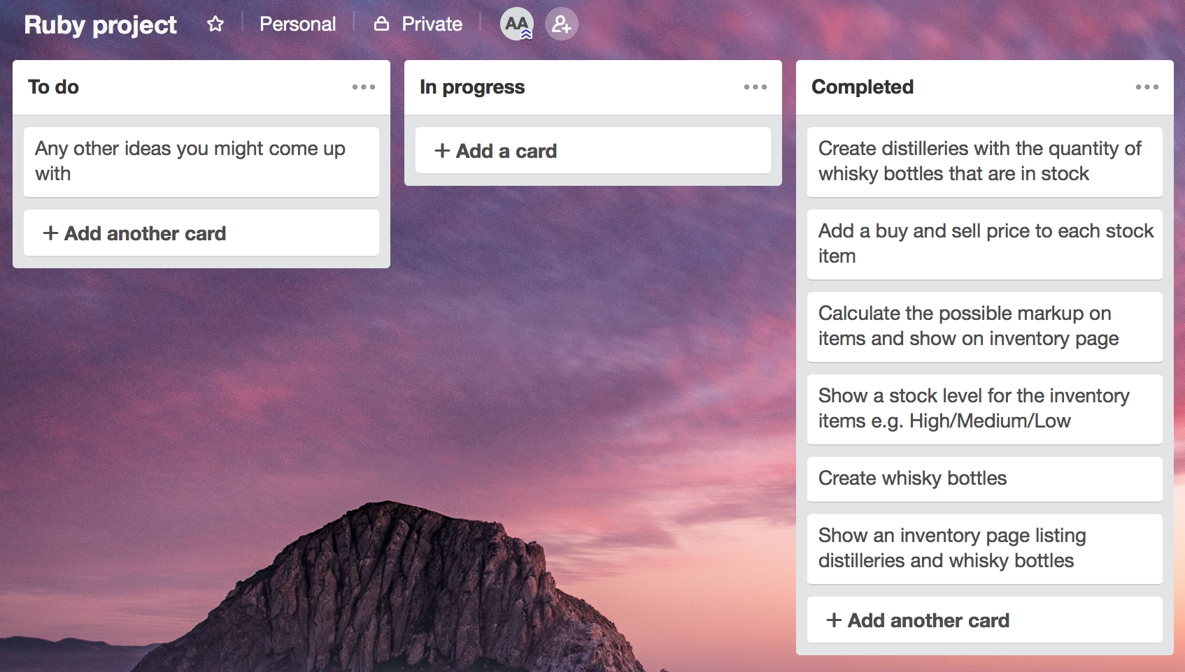

WEEK_11

Demonstrate testing in your program. Take screenshots of:

Example of test code

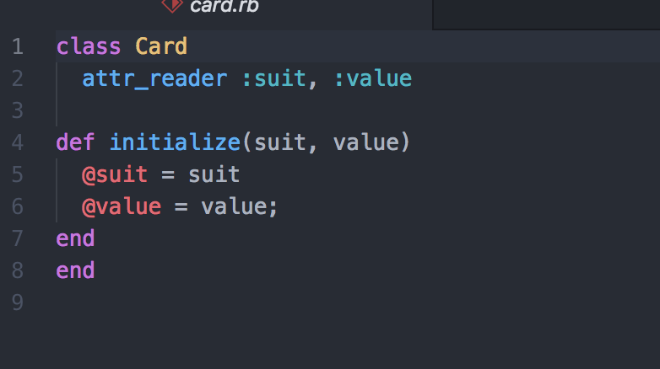

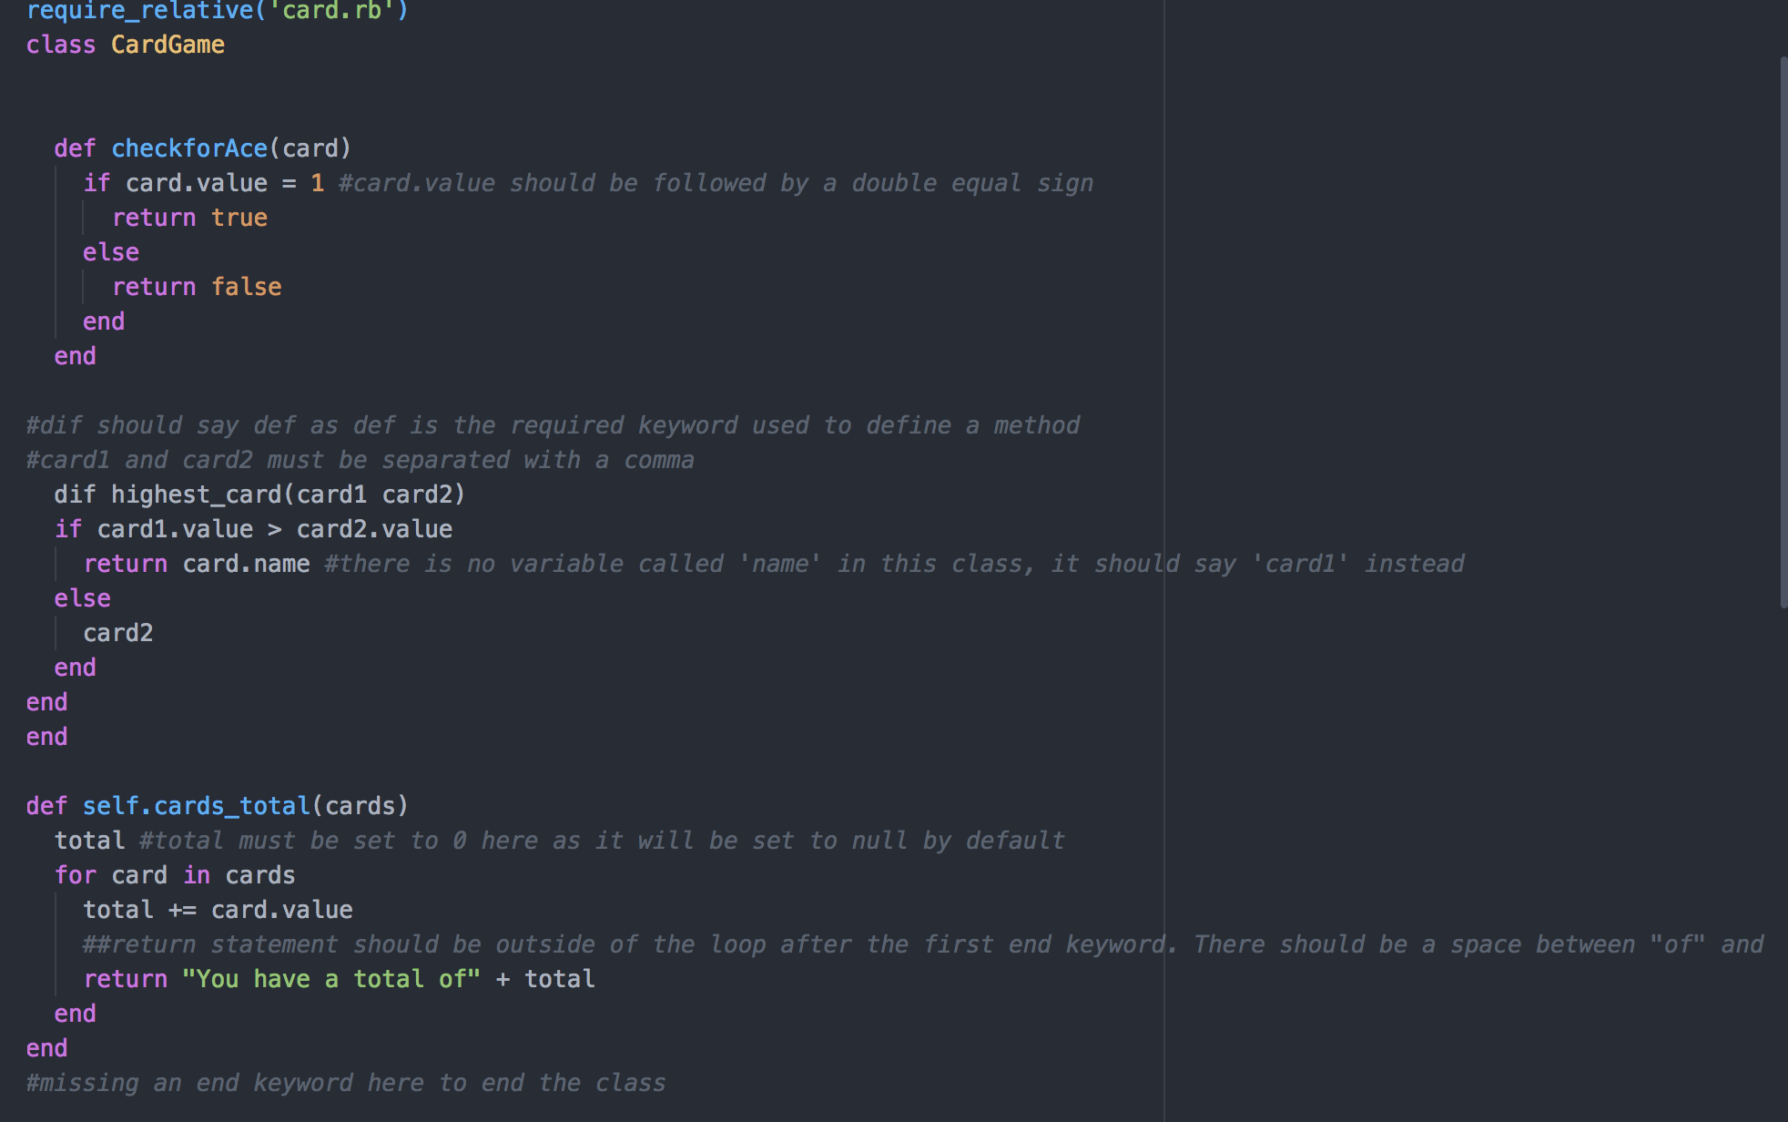

Specs file

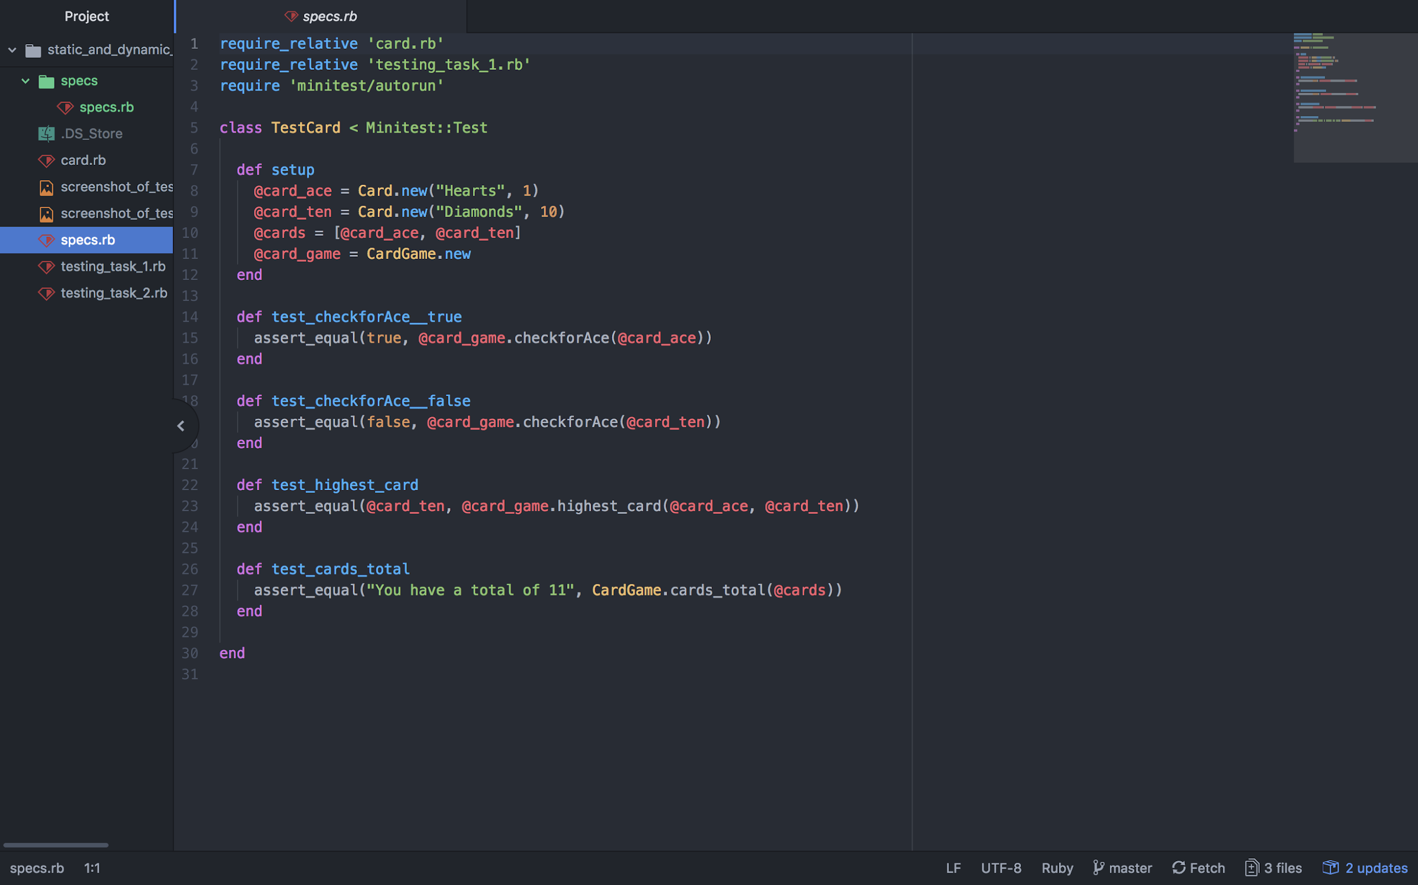

The test code failing to pass

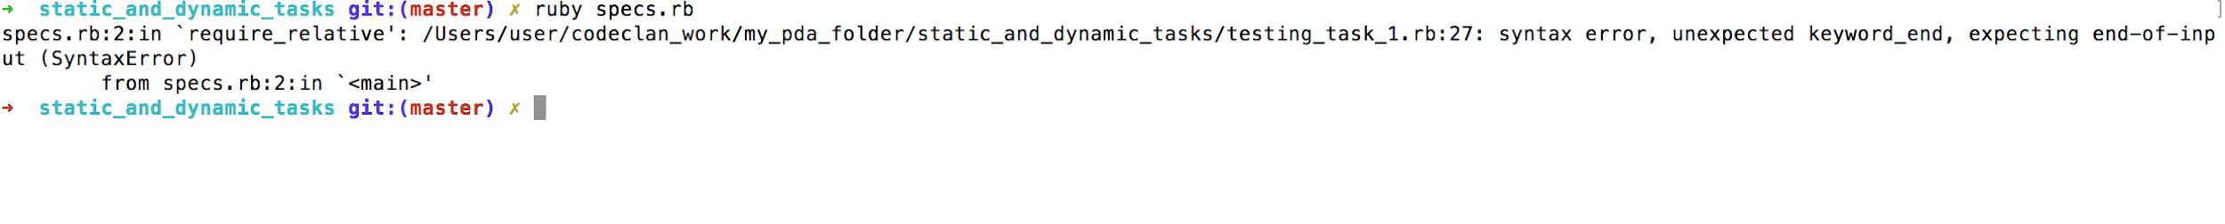

Example of the test code once errors have been corrected

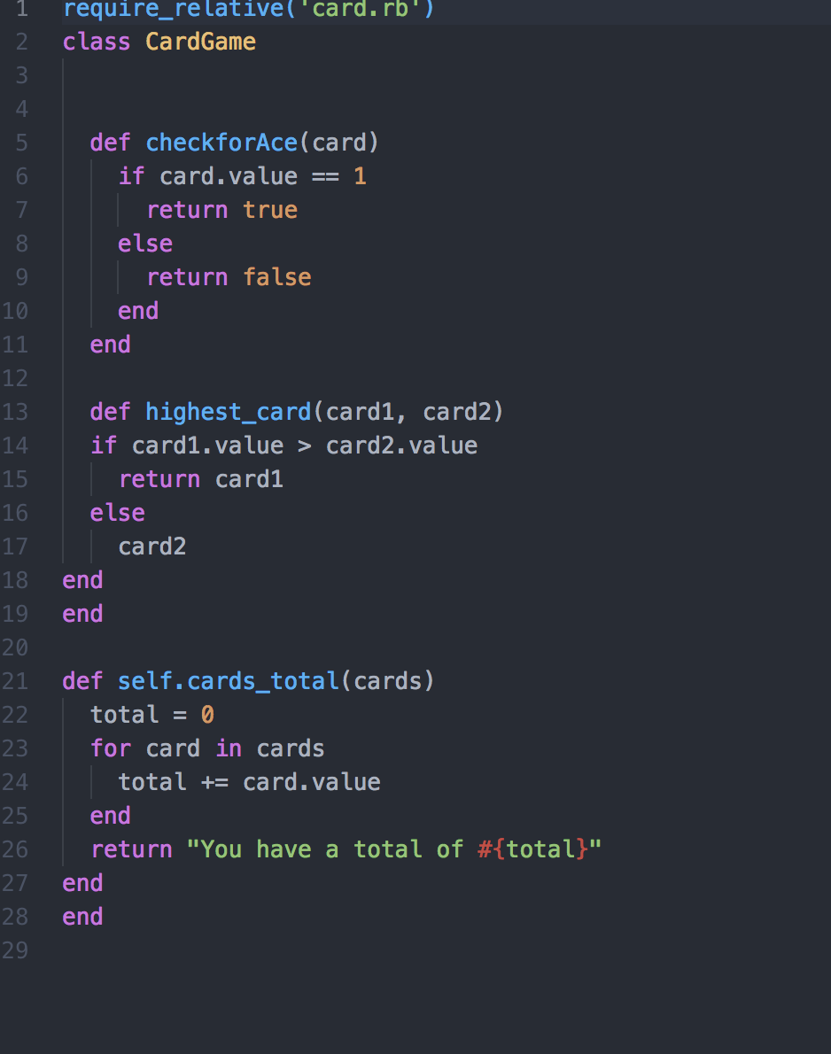

The test code passing

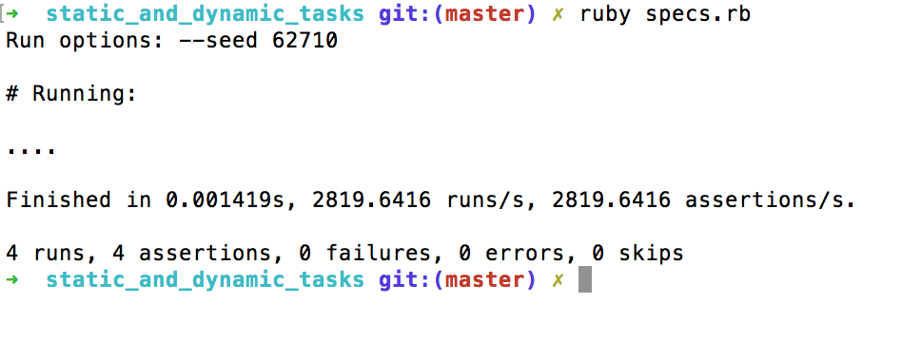

WEEK_12

Show an API being used within your program. Take a screenshot of:

The code that uses or implements the API

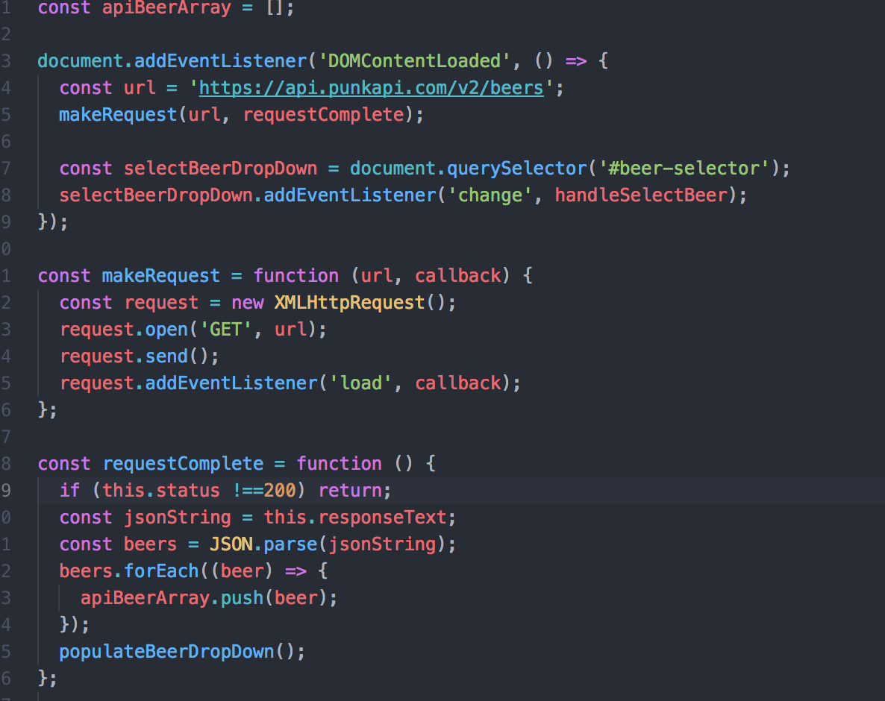

The API being used by the program whilst running

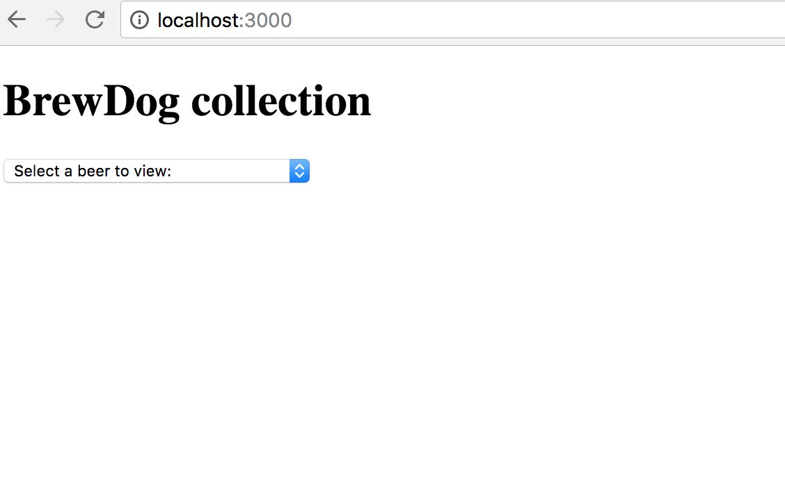

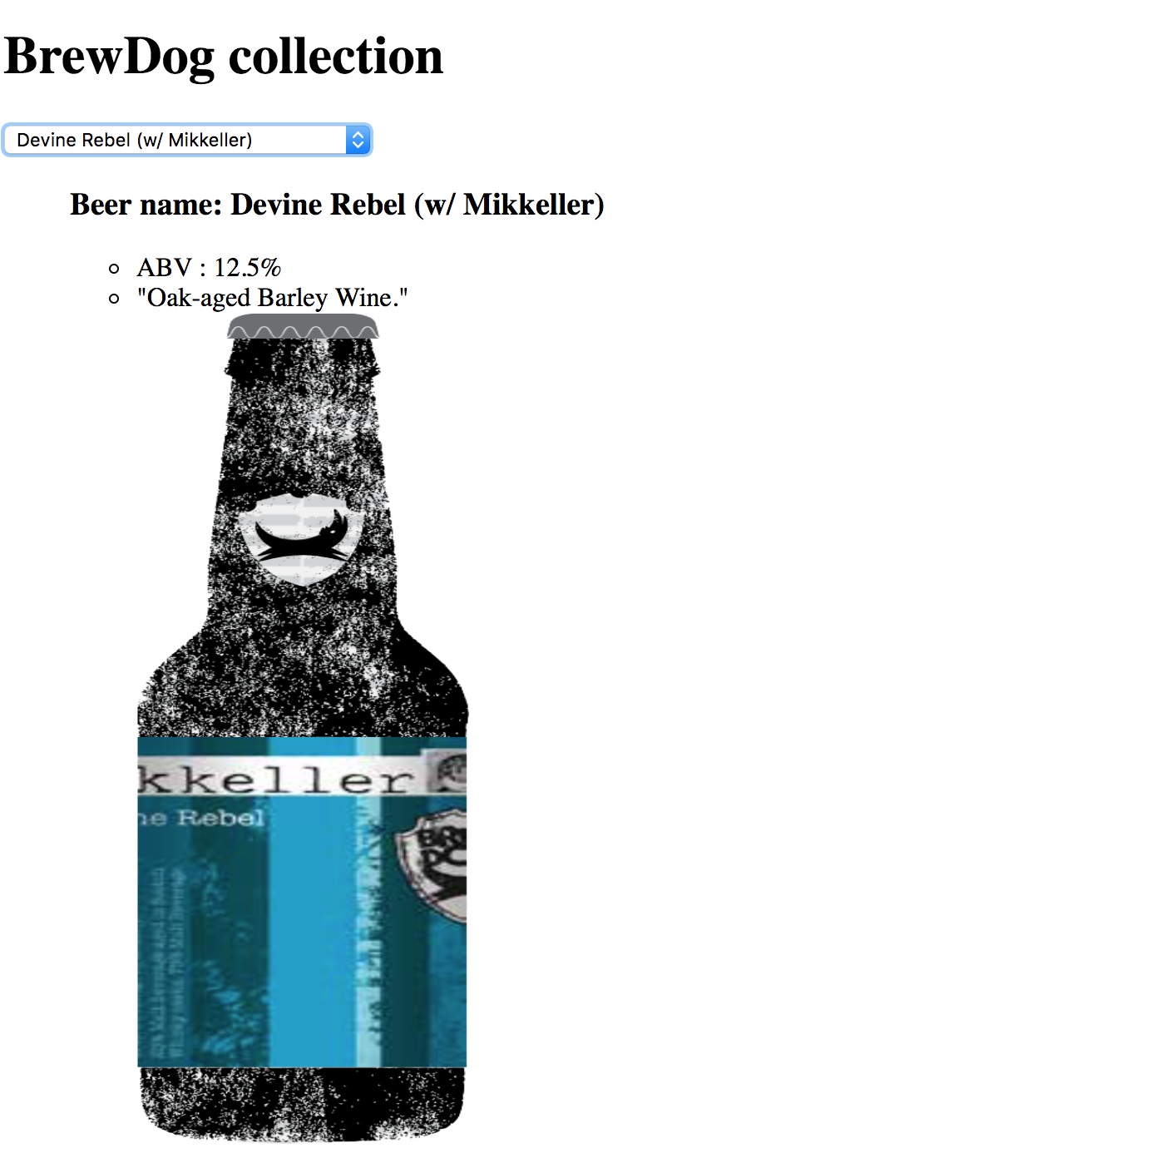

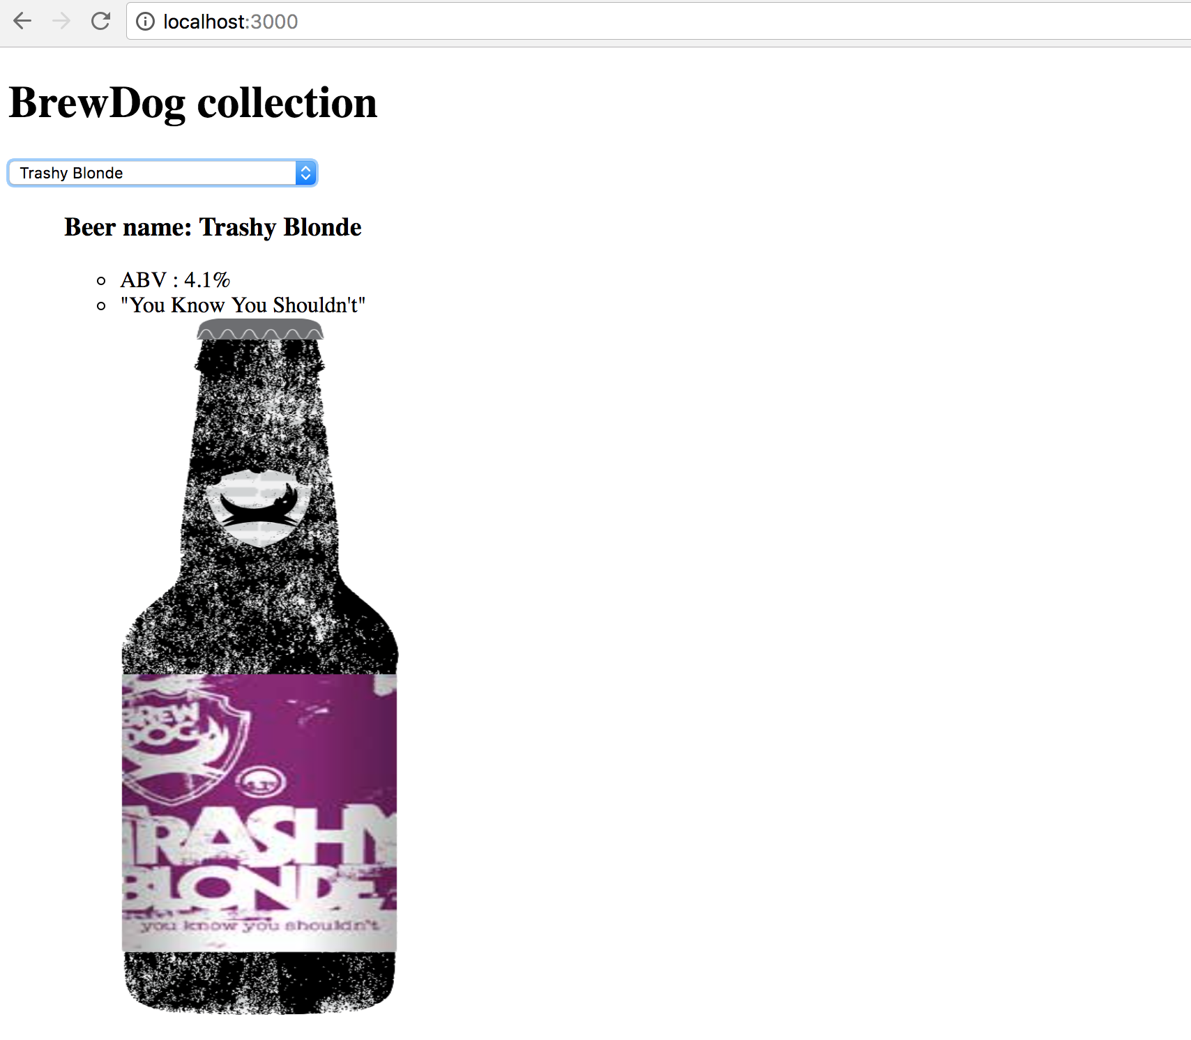

WEEK_14

Take a screenshot of contributor’s page on GitHub from your group project to show the team you worked with

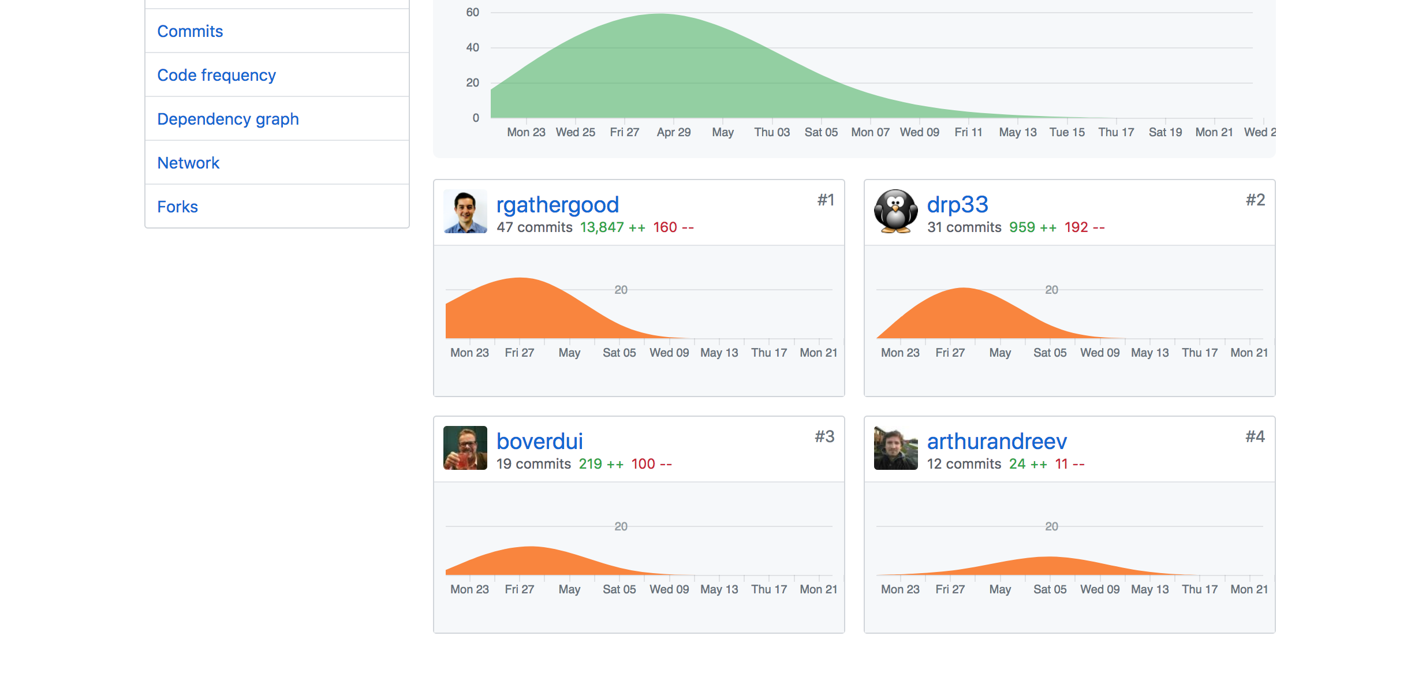

Take a screenshot of the project brief from your group project

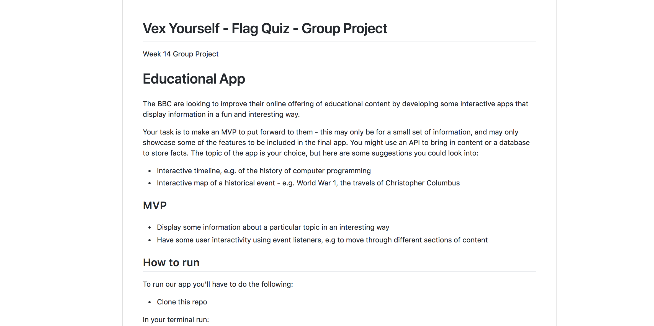

Provide a screenshot of the planning you completed during your group project 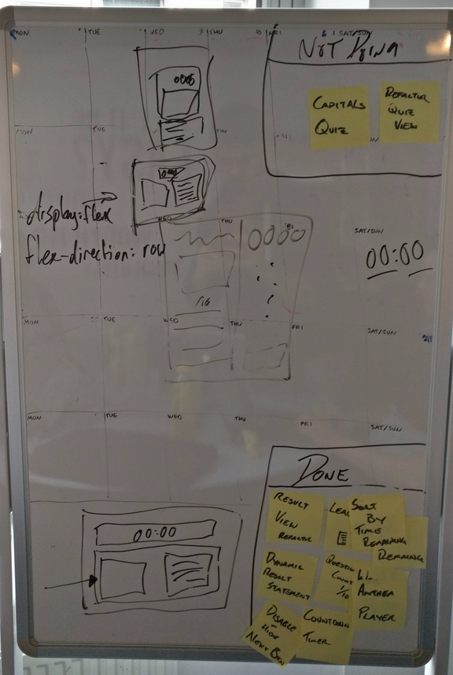

Write an acceptance criteria and test plan

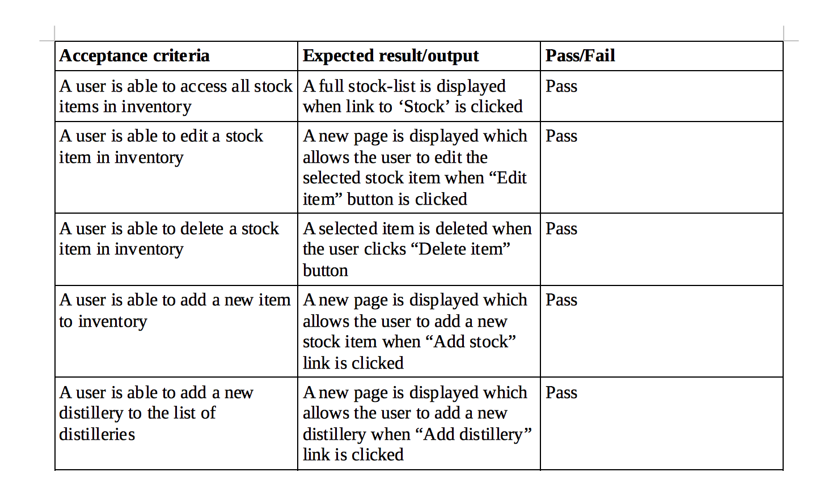

**Do i need to include at least one Fail outcome here???**

Produce two system interaction diagrams(sequence and/or collaboration diagrams)

**Diagram 1**

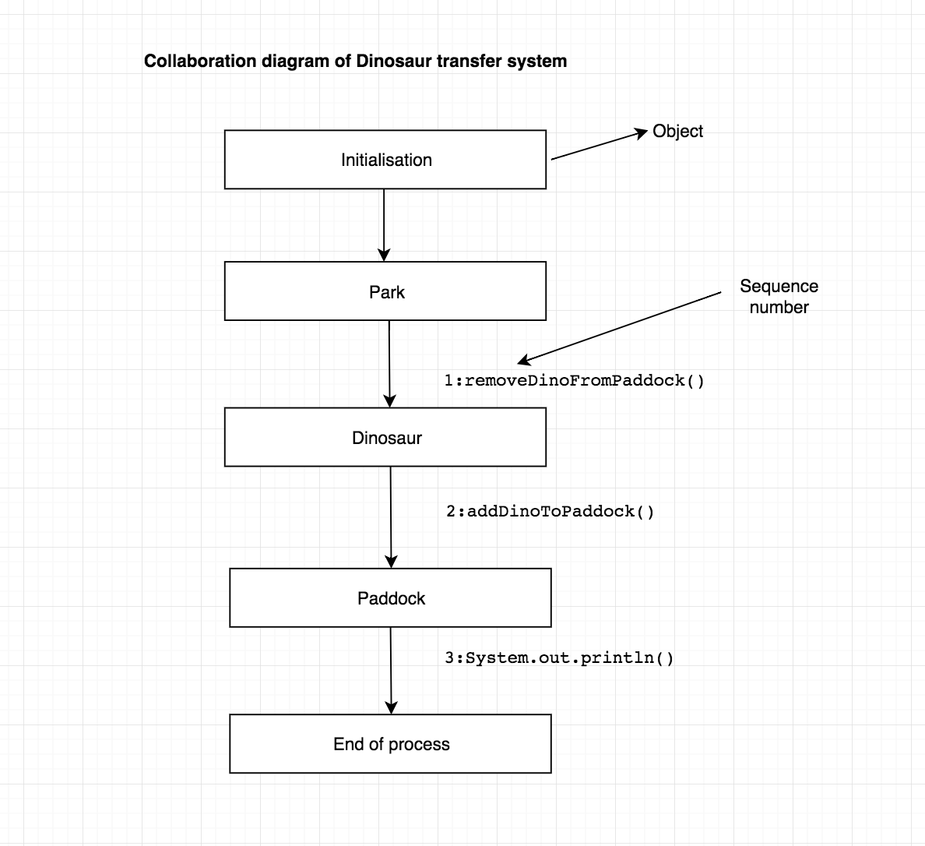

**Diagram 2**

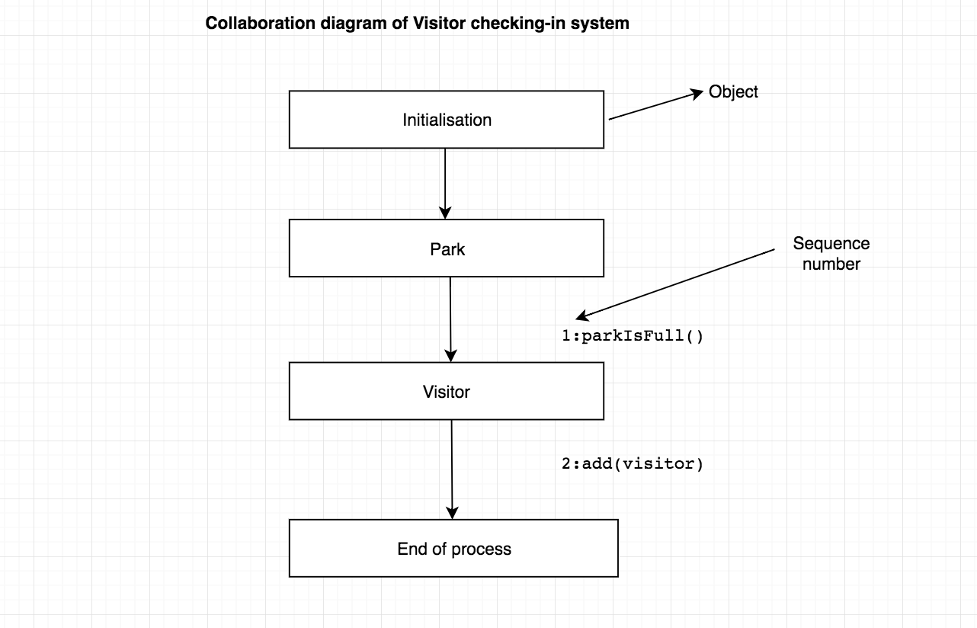

Produce two object diagrams

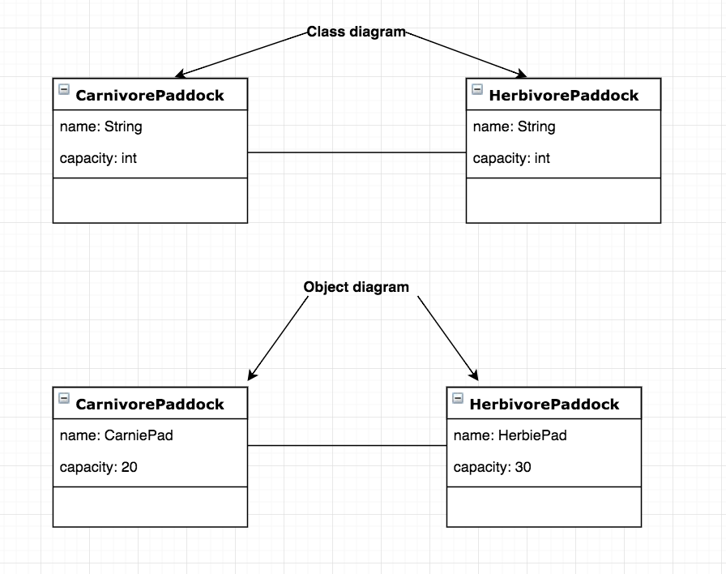

Select two algorithms you have written(not the group project). Take a screenshot of each and write a short statement on why you have chosen to use those algorithms

1) **addDinosaurToPaddock()**

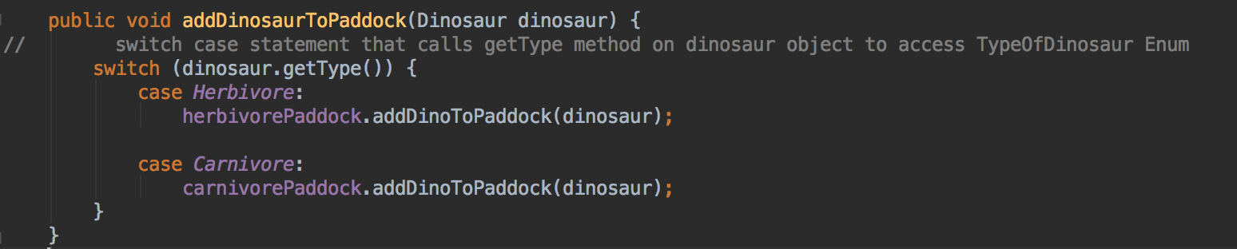

This method adds different types of dinosaurs (herbivore/carnivore) in separate paddocks as they can’t reside in the same paddock. I chose this method because I needed to write an algorithm for checking what type of dinosaur has been passed in to my method and then add this dinosaur object to the correct paddock. I used a switch/case statement here which is passed in the getType()method that returns the type of dinosaur object passed in (herbivore or carnivore which is stored in an Enum). These are the only two types that exist in the Enum hence there are two corresponding cases for Herbivore and Carnivore. addDinoToPaddock() method adds the dinosaur object to the correct paddock depending on whether dinosaur is herbivore or carnivore.

2) **transferDinosaur()**

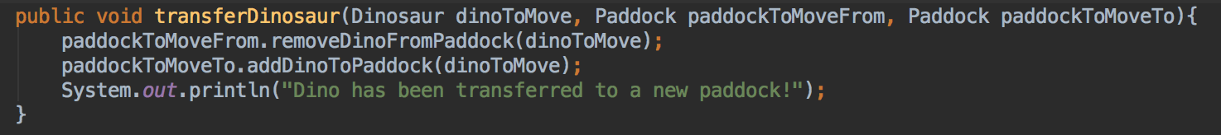

I chose this method because I needed to write an algorithm that would allow me to transfer dinosaurs between paddocks.

This method takes in three parameters: dinosaur, paddockToMoveFrom and paddockToMoveTo.

First step in this algorithm is calling removeDinoFromPaddock method on paddockToMoveFrom and passing it our dinosaur object. This will remove our dinosaur from paddock.

Second step is calling addDinoToPaddock method on paddockToMoveTo and passing it our dinosaur object. This will add our dinosaur to a new paddock.

Finally a message will be printed out to the console that will read “Dino has been transferred to a new paddock”.

Produce a bug tracking report

